Theresa Rita (Johnson) Thompson
June 16, 1926 – October 12, 2016

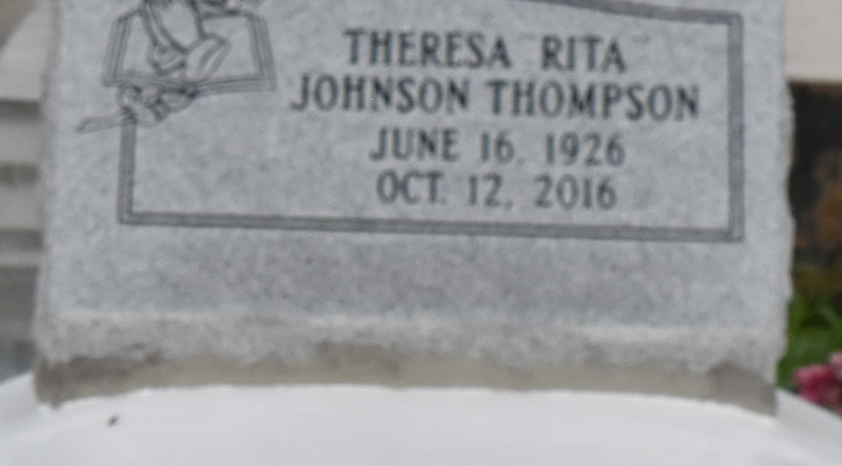

A native of Paulina and a resident of Convent. She passed away at 2:20 A.M., Wednesday, October 12, 2016 at her daughter's residence in LaPlace. She was 90.
Visiting at Mt. Olive Baptist Church in Paulina, Saturday, October 22, 2016 from 9:30 A.M., until religious services at 11:00 A.M. ONLY, conducted by the Rev. Oscar Nelson, Sr. Interment in Antioch Cemetery in Paulina.
Survived by two daughters: Elaine (Leon) Mason, Sr. and Eloise (Rev. Reginald) Holmes. Three Sons: Nelson,Jr. (Cynthia) Thompson, Gabriel (Kim) Thompson and Kenneth (Adrain) Thompson, 10 grandchildren, 4 great grandchildren, numerous nieces, nephews, cousins, other relatives and friends. Preceded in death by her parents, Freddie Johnson and Dora Smith Johnson, Her husband, Nelson Thompson, Sr., Sisters: Albertha Marcell, Aldonia Johnson, Estella Joseph and Alma Martin. Brothers: Arthur, Alfred, Frank, Theodore, and Rev. John Henry Johnson. BRAZIER-WATSON FUNERAL HOME IN CHARGE OF ARRANGEMENTS. Visit us at www.brazierwatson.com to sign our guest book.

The Advocate, Baton Rouge, Louisiana
Oct. 20 to Oct. 22, 2016

