Clemontine W. (Turner) Traveler
1912 – December 14, 2000

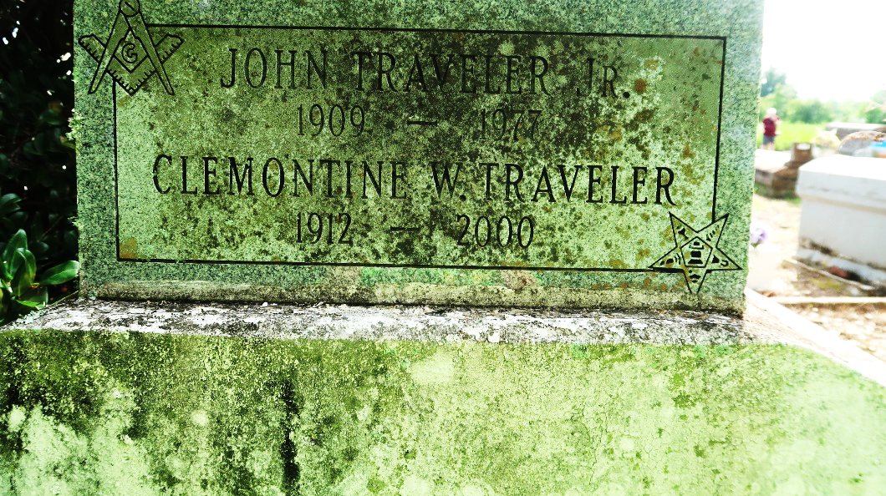

Clemontine "Clem" "Big Mama" Turner Traveler, 88, a native and resident of Lutcher, died Dec. 14, 2000.
She was the wife of the late John Traveler Jr., and mother of Mayola Beverly, Walter Sr. and Isaac Traveler, and the late Carolyn, Mary Lee and Pearly Traveler, and stepmother of the late Alvin Traveler.
She was the daughter of the late William and Lorena Russell Turner, and sister of Hazel Wallace, John Turner, and the late Ollie, Alvin and Ernest Turner.
She is also survived by 11 grandchildren, 11 great-grandchildren and two great-great-grandchildren.
Services are today at 11 a.m. at King David Baptist Church, Lutcher, with interment at Antioch Cemetery, Paulina. Visitation starts at 9:30 a.m.

Unknown source

