Isaac Allie Traveler
January 20, 1941 – July 3, 2015

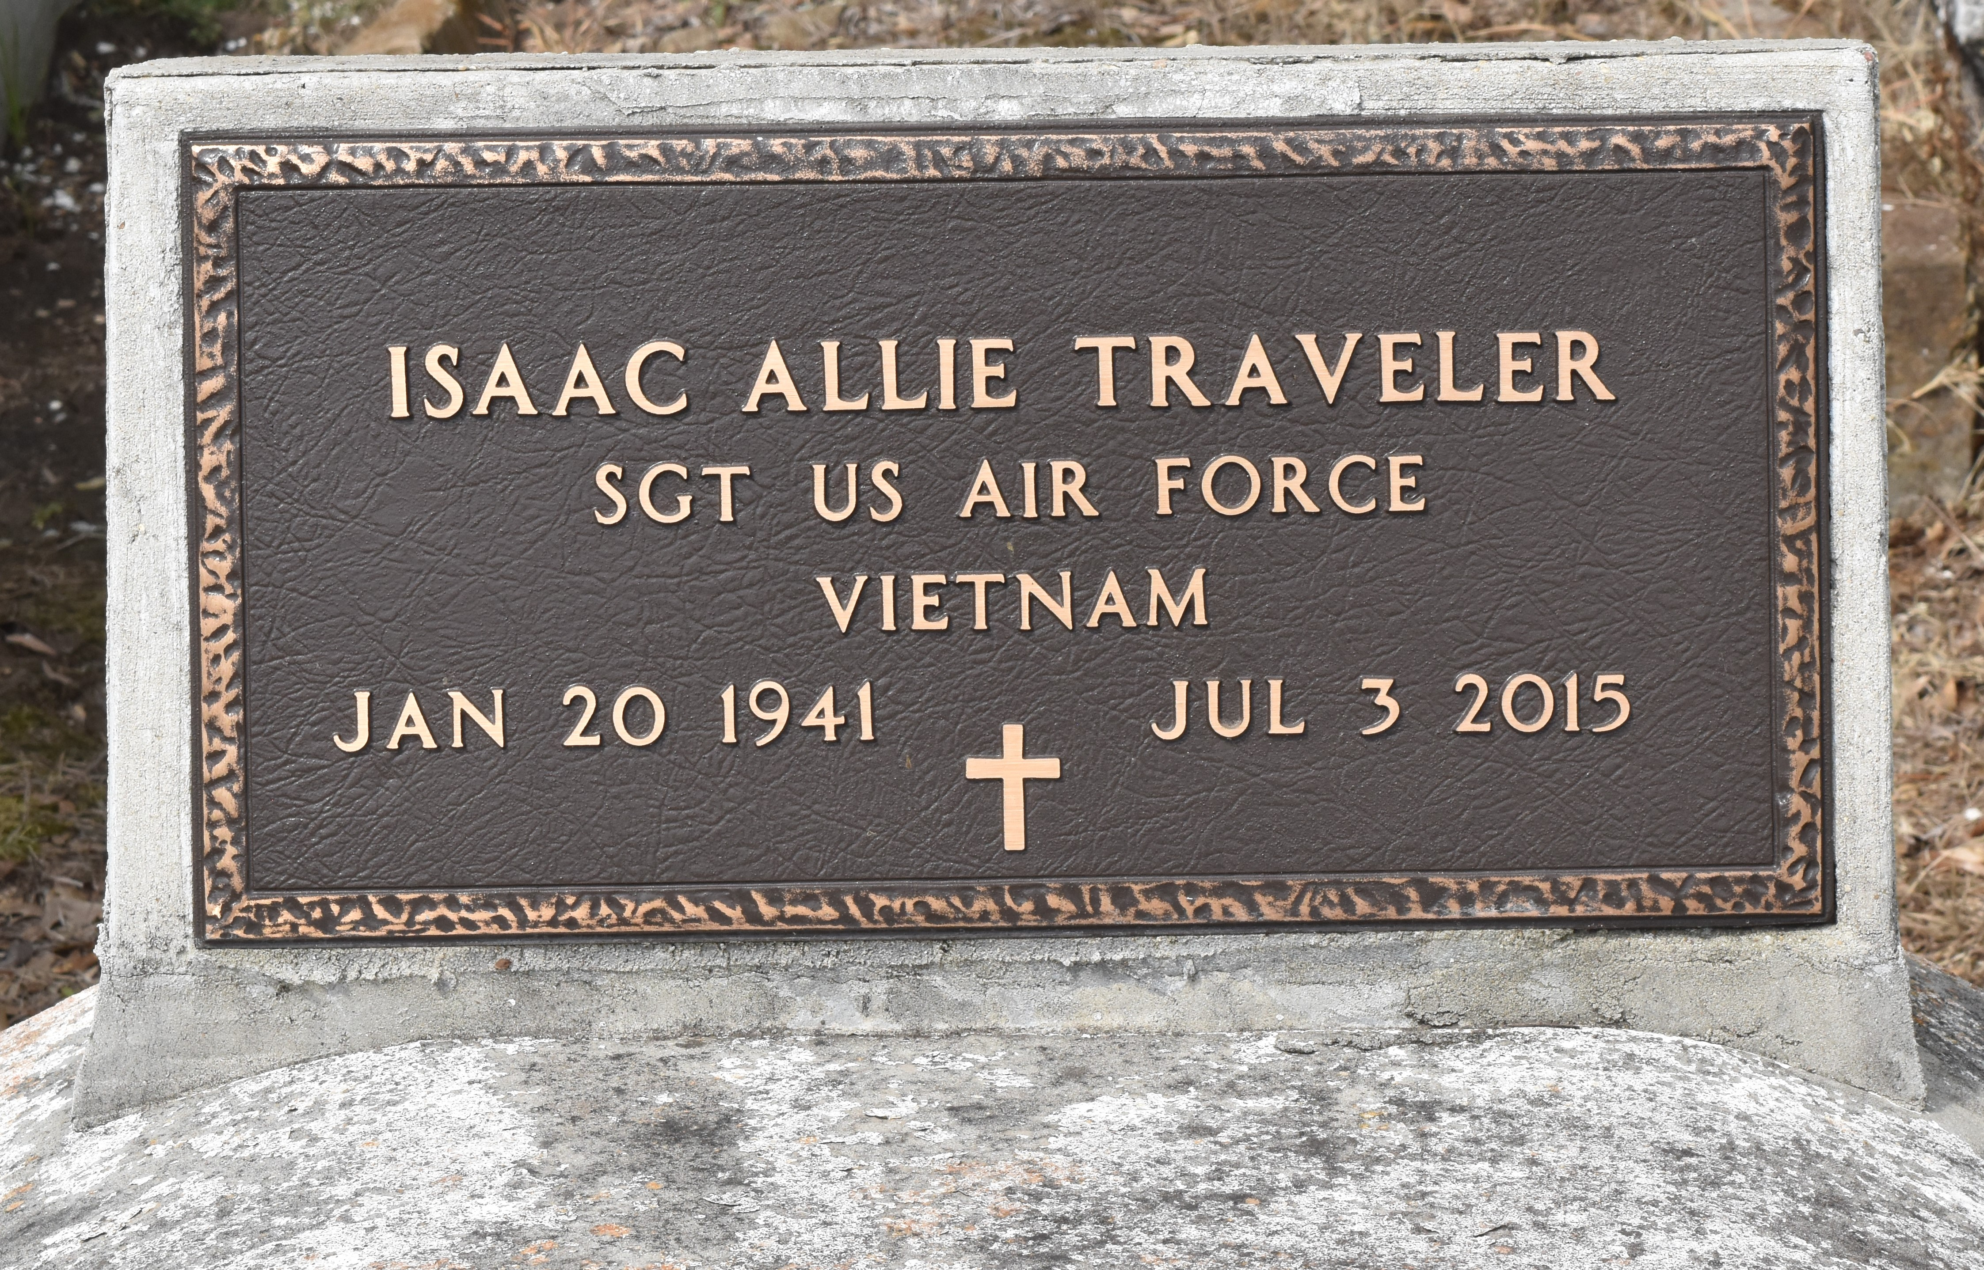

Isaac "Piggy" Traveler at the age of 74 years departed this earthly life at his residence surrounded by his family on Friday July 3, 2015.
Beloved husband of Sabiha O. Traveler of Laplace, La. Loving father of Alkan A. Traveler Sr. Father-in-law of Tara Traveler of Luling, La. Grandfather of Alkan Jr. and Alexis Traveler. Brother of Mayola T. Beverly of Bakersfield, Ca. A devoted friend, Harry Stipe of Laplace La. and a host of nieces, nephews other relatives and friends. A native of Lutcher La and a resident of Laplace, La. He served in the U.S. Airforce for 23 years.
Funeral services will be Friday July 10, 2015 at 10:00 am at Bardell's Mortuary 3856 Hwy 44 Mt. Airy, La Rev. Rodney Johnson of Bethlehem Baptist Church of Hahnville, La. officiating. Interment in Antioch Cemetery of Paulina, La Visitation will be from 9:00 am until service time at Bardell's Mortuary. Bardell's Mortuary of Mt. Airy, La in charge. Information: 985-535-6837.
The Times-Picayune, New Orleans, Louisiana
Jul. 7 to Jul. 8, 2015

