Frederick Marquese Ursin
September 4, 1979 – May 25, 2001

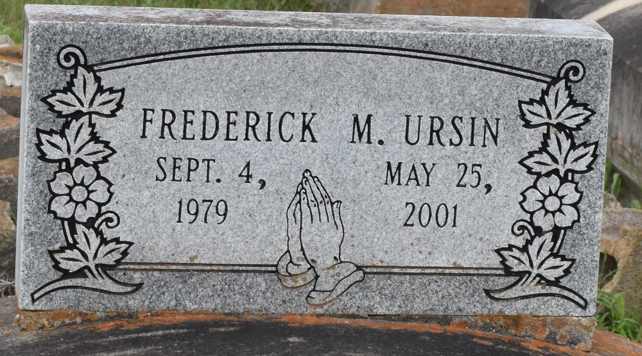

Frederick Marquese Ursin, 21, a resident of Paulina, died May 25, 2001, in an automobile accident in Bristol, TN.
He was the son of Molen and the late Geraldine Ursin and brother of Carisa Ursin, Nicole Jones and Ricou J., Travis, Calvin and the late Trashira Ursin.
Dismissal services are today at 11 a.m. at Evergreen Baptist Church, Paulina, with interment at Antioch Cemetery, Paulina.

Unknown source

