Geraldine J. Ursin
November 13, 1956 – May 25, 2001

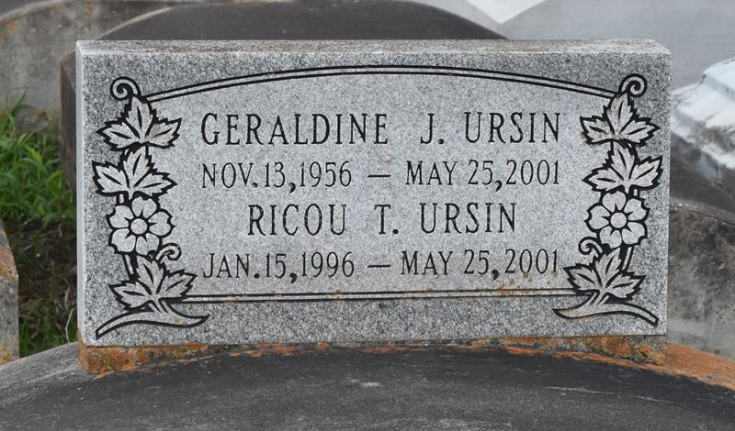

Geraldine "Jean" Ursin, 46, a native of Paulina and resident of Woodville, MS for the past 13 years, died May 25, 2001, in an automobile accident in Bristol, TN.
She was the mother of Carisa, Ricou, Travis, Calvin and the late Frederick and Trashira Ursin. She was also the sister of Jerry Mae Clayton. She is also survived by three grandchildren. She attended Lutcher High School.
In the same accident, Frederick Ursin, 21, Trashira Ursin, 16, and grandchild, Ricou Terrell Ursin, 5, also died.
Dismissal services are today at 11 a.m. at Evergreen Baptist Church, Paulina, with interment at Antioch Cemetery, Paulina.

Unknown source

