Ricou Terrell Ursin
January 15, 1996 – May 25, 2001

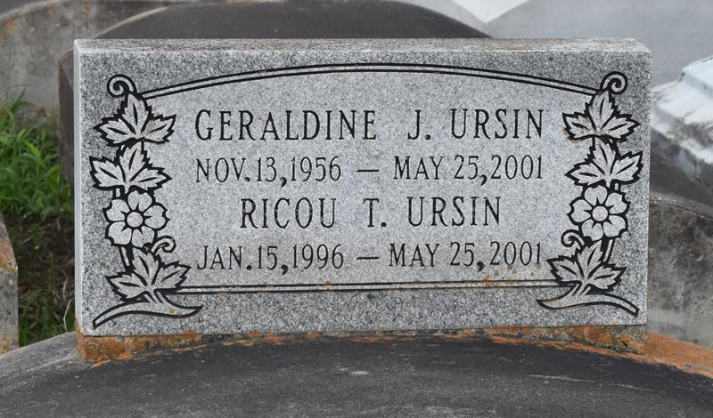

Ricou Terrell Ursin died Friday from injuries sustained in a car accident in Bristol, Tenn. He was 5. He was born in New Orleans and lived in Woodville, Miss.

Survivors include his parents, Ricou Ursin and Ekeisha Green; his grandparents, Molen and JoAnne Ursin and Emma and Alvin Green; a brother, Tyree Ursin; and a sister, Kayleagh Green.

A funeral will be held Friday at 7 p.m. at Wilkinson County High School in Woodville. A dismissal service will be held Saturday at 11 a.m. at Evergreen Baptist Church in Paulina. Burial will be in Antioch Cemetery in Paulina. Bardell's Mortuary is in charge of arrangements.

Times-Picayune, The (New Orleans, LA)
Thursday, May 31, 2001

