Trashira J. Ursin
January 31, 1985 – May 25, 2001

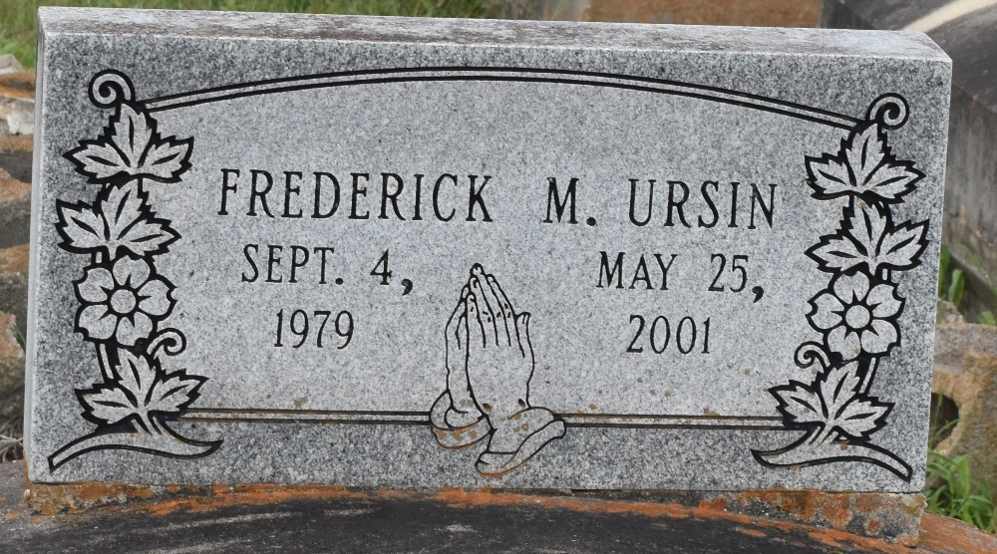

Trashira J. Ursin, 16, a resident of Paulina, died May 25, 2001 in an automobile accident in Bristol, TN.
She was the daughter of Johnny Jackson and the late Geraldine Ursin and sister of Carisa, Ricou J., Travis, Calvin and the late Frederick Ursin.
Dismissal services are today at 11 a.m. at Evergreen Baptist Church, Paulina, with interment at Antioch Cemetery, Paulina.

Unknown source

