Wallace Vallery
March 16, 1943 – February 5, 2003

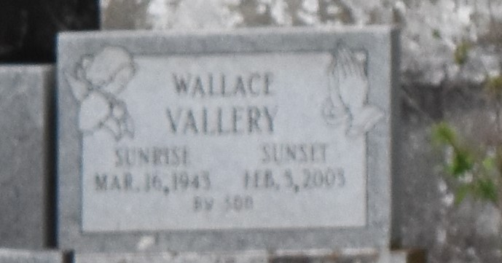

PAULINA – Wallace Vallery, 59, a native of Convent and resident of New Orleans, died Feb. 3. He was the father of Paul Vallery and stepfather of Devron Deon. He was also the son of the late John and Mable Stewart Vallery, and brother of Mary, Audrey, Erma, Dorothy, Tilda, Connie, Laura Ann, Ray-mond, Edmond, Leonard, Ronald and Neal Vallery, and the late Joseph, Alvin and Bernard Vallery.

Services are today at 11 a.m. at Mt. Olive Baptist Church, Paulina, with interment at Antioch Cemetery, Paulina. Visitation starts at 9 a.m.
L’Observateur, LaPlace, Louisiana
February 17, 2003

