George James Washington Jr.
September 16, 1932 – September 2, 2019

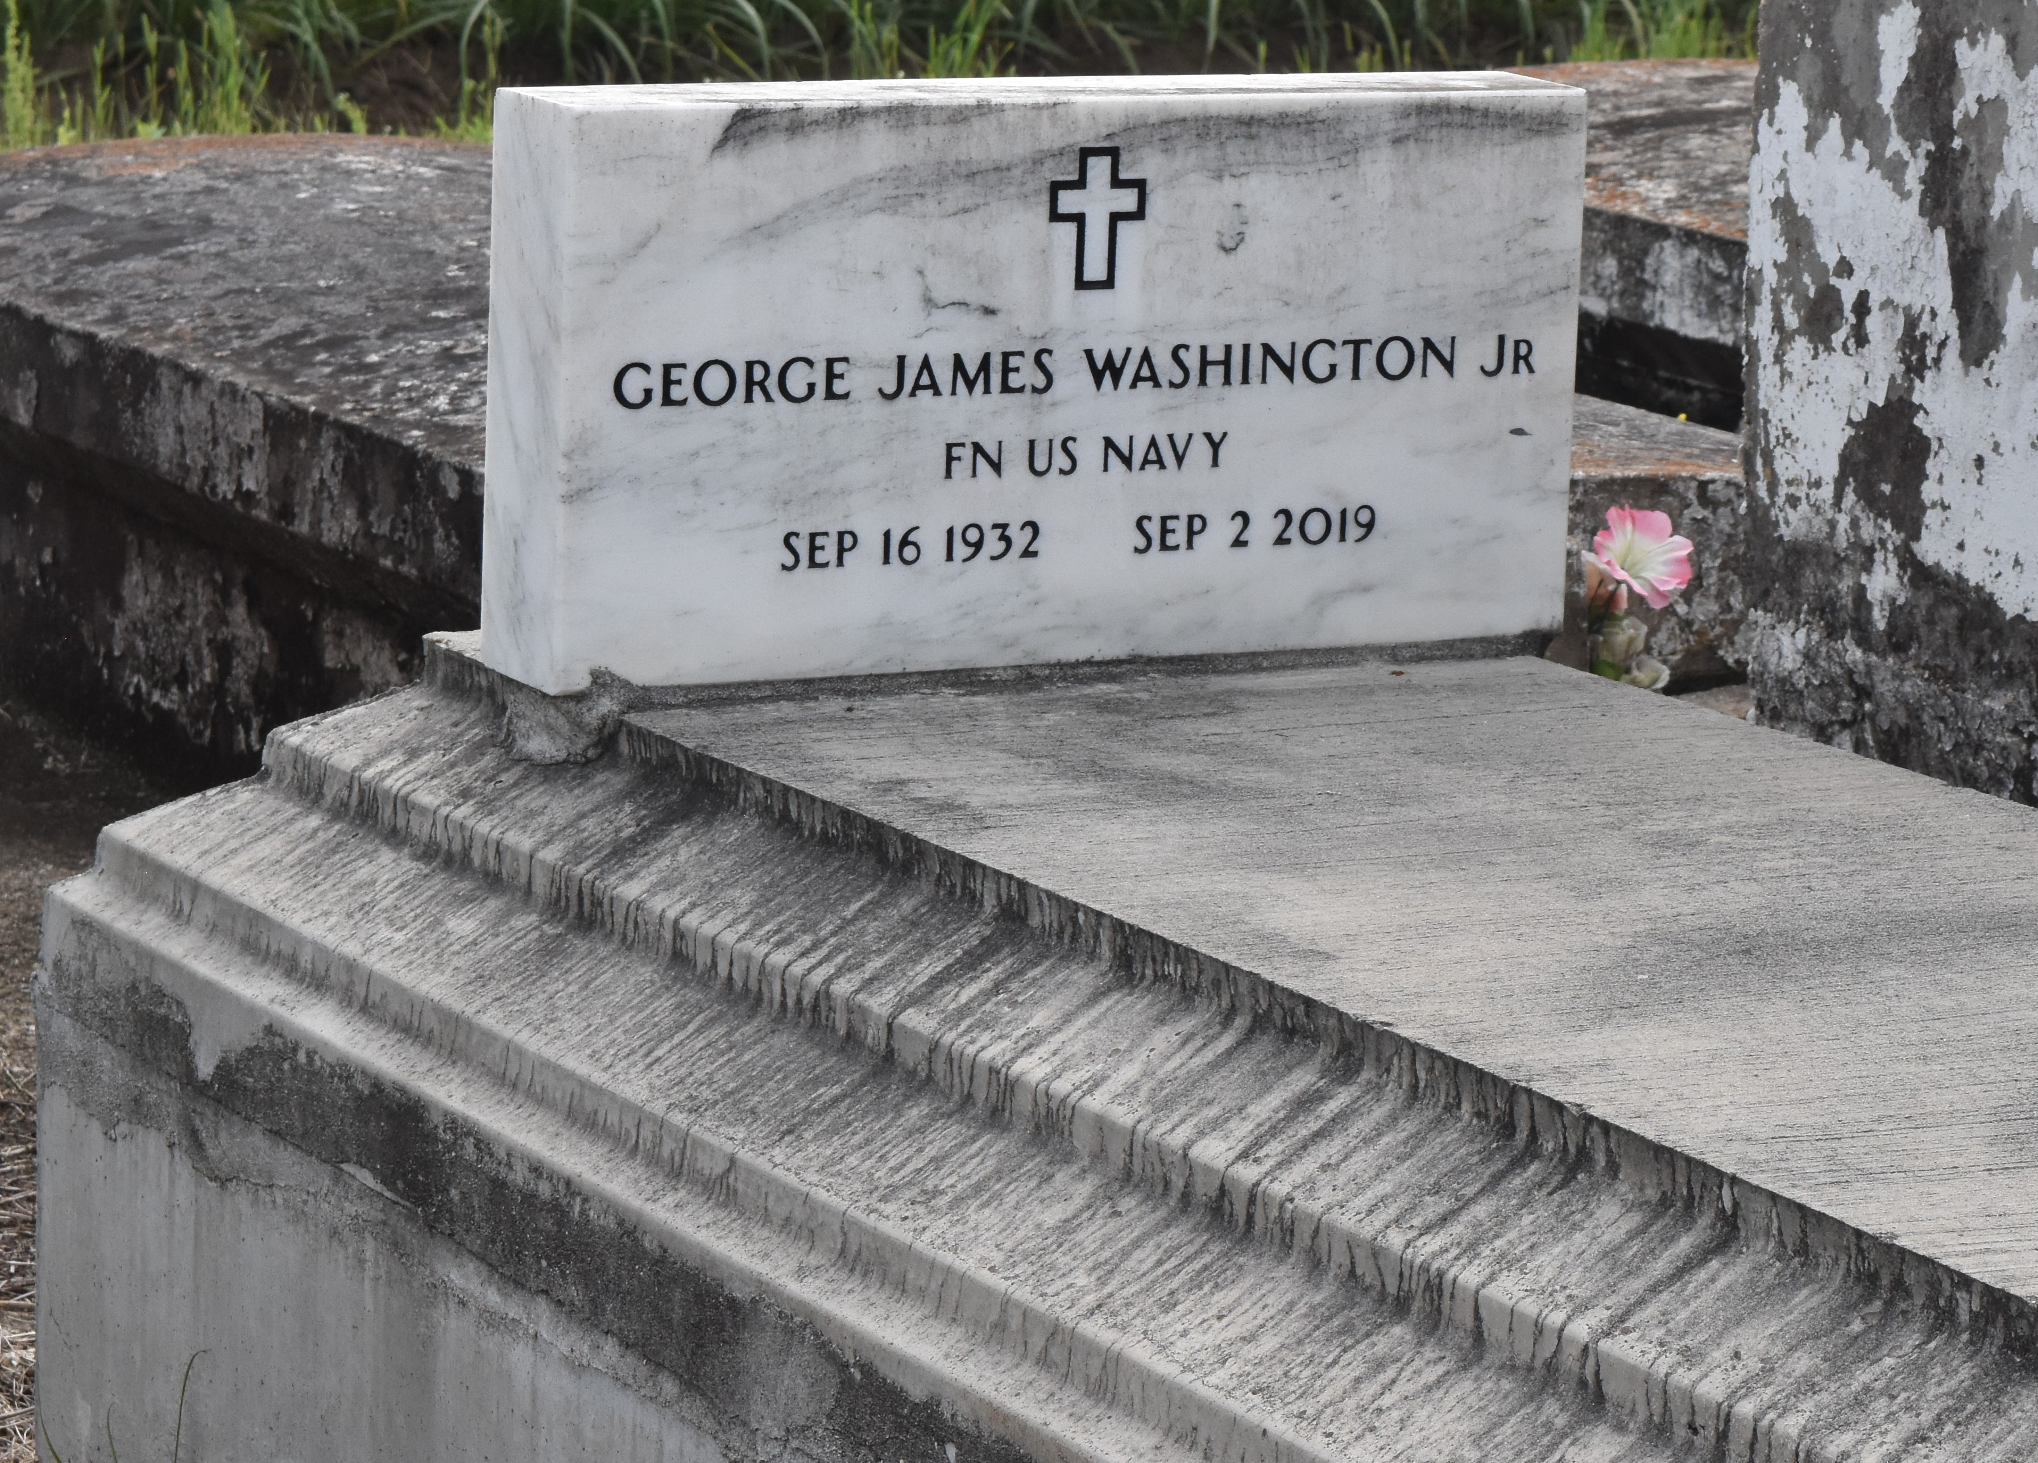

George James "Bolo" Washington, Jr., a native and resident of Lutcher. He passed away peacefully at his residence surrounded by his family at 7:27 p.m., Monday September 2, 2019. He was 86.
Visiting at King David Baptist Church, King Avenue, Lutcher, Thursday, September 12, 2019 from 9:30 a.m. until Religious Services at 11:00 a.m.,conducted by the Rev. Ferdinand Wallace, Jr. Interment in Antioch Cemetery in Paulina.
Survived by his wife, Burna Washington Washington. Daughters: Patricia (Roosevelt) Piper, Elaine Grimes, Jacquelyn and Glassy Washington, Chantell (Shawn, Sr.) Hall and Danielle (Carmelia) Garrett. His sons: Johnny (Dorothy) Grimes, Gregory Lane and Carl Cooper. His sister: Esther Johnson. Brothers: Alvin (Joyce) Washington, Ralph and Kent Washington. Sisters-in-law: Bridgett (Darnell) Williams and Kerri Ann Williams. Daughter-in-law: Monique Thomas; 40 grandchildren, 62 great-grandchildren, 15 great-great grandchildren, numerous nieces, nephews, cousins, other relatives and friends.
Preceded in death by his parents: George Washington, Sr. and Louvenia Butler Washington. His son: Clint Thomas. His daughters: Janet Stevens and Enola Brown. Sisters: Geraldine Lawrence, Diane Washington and Audrey Wallace. A brother, Larry Washington. Father and mother-in-law, Robert and Delores Washington, Jr. and sisters and brothers-in-law. BRAZIER-WATSON FUNERAL HOME IN CHARGE OF ARRANGEMENTS. Visit us at www.brazierwatson.com to sign our guest book.

The Advocate, Baton Rouge, Louisiana
Sep. 10 to Sep. 12, 2019

