Brenda Ann W. Weber
January 17, 1948 – September 3, 2017

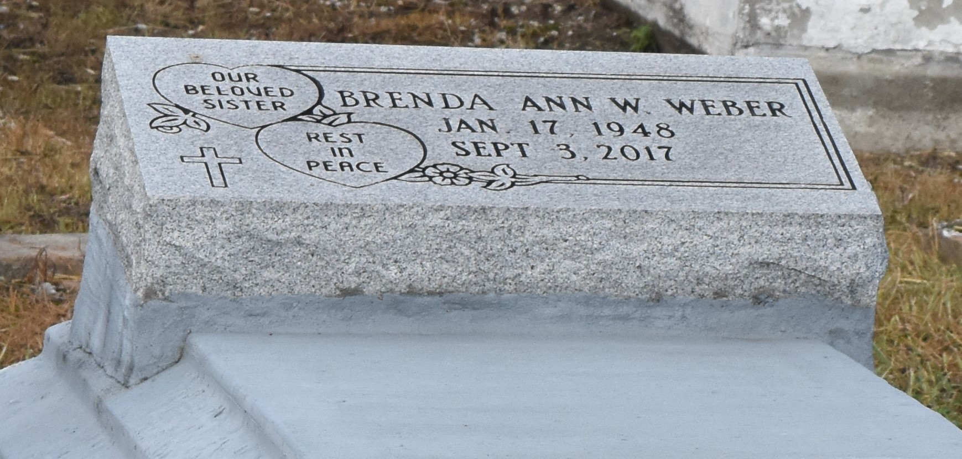

Brenda A. W. Weber departed this life on Wednesday, September 6, 2017.. Sister of Lawrence and Clayton Poche Jr., Step Mother of Valean, J.R., and Stanley Ricks and a host of nieces, nephews, other relatives and friends. Age 69.
Celebration service on Wednesday September 13, 2017 at 11:00am at Israelite B.C., 2192 Alexander St, Lutcher, LA 70071. Rev. Kevin Fredericks, Pastor officiating, Interment in Antioch Cemetery, Paulina, La. Viewing at 9:00am. Until service time. Service entrusted to HOBSON BROWN FUNERAL HOME, 134 DAISY ST. GARYVILLE, LA, (985) 535-2516.

The Advocate, Baton Rouge, Louisiana
Sep. 10 to Sep. 12, 2019

