Albert Williams Sr.
September 9, 1926 – September 24, 2010

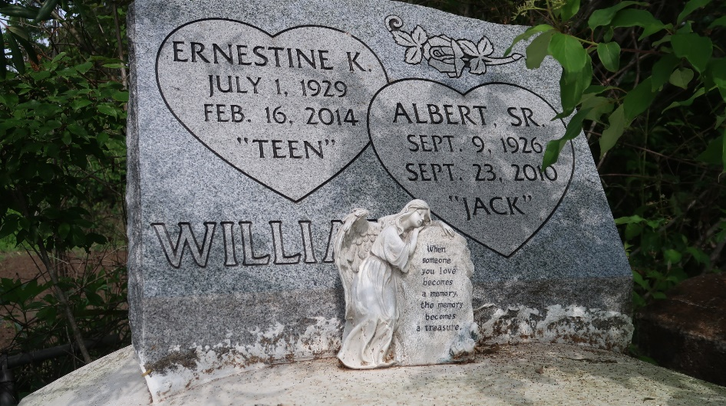

Albert Williams, Sr. entered into eternal rest on Friday, September 24, 2010, at Ochsner Hospital in Kenner, La., at the age of 84. Son of the late Philip and Stella Williams Sr. Husband of 65 years to Ernestine Kirklin Williams. Father of Ernestine Albert, Fannie Bolden, Jacqueline Steptoe, Patricia Joseph, Melissa Leblanc, Katherine Clayton, Glenda, Lisa, Sandra, Albert Jr., and Shelton Williams, the late Carl, Michael, Michelle, and Rochelle Williams. Also survived by 23 grandchildren, 14 great-grandchildren, sons- and daughters-in-law, a host of nieces, nephew, cousins and friends. A native of Lucy, La. and a resident of Paulina, La.
Relatives and friends of the family; pastors officers, and members of St. Matthew B.C. and all neighboring churches are invited to attend the Funeral Service on Wednesday, September 29, 2010 at 11:00 a.m. at the above named Church, 3582 Hwy. 44, Paulina, La. Rev. Alfred Bejole, Pastor - Officiating. Visitation on Tuesday from 5:30-7:00 p.m. at the Funeral Home and at 9:00 a.m. on Wednesday at the church. Interment in Antioch Cemetery, Paulina, LA. Professional Service Entrusted to Hobson Brown Funeral Home Garyville, La 70051 (985) 535-2516.

The Times-Picayune, New Orleans, Louisiana
Sep. 28, 2010

