Artemise (Ezidore) Williams
September 16, 1920 - February 27, 2011

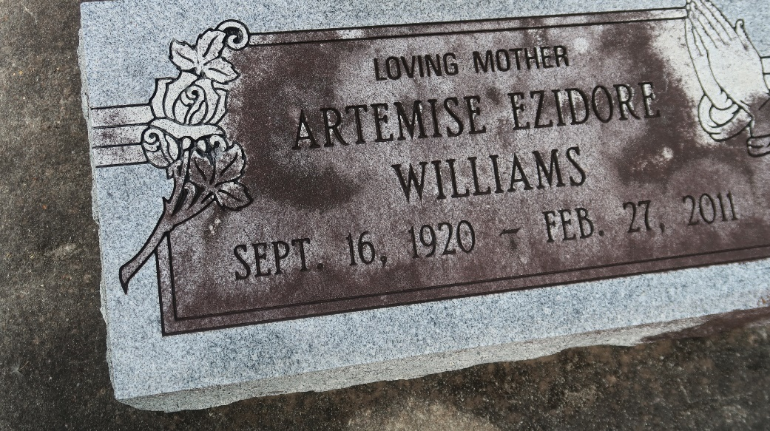

Artemise Ezidore Williams at River Parish Hospital, LaPlace, LA, at 9:23 p.m., Sunday, February 27, 2011. Daughter of the late Sidney Ezidore and Annie Minor Ezidore. Wife of the late Marshall Williams, Sr. Beloved mother of Annie Lee (James) Emery, Artemise (Joseph) Bernard, Stella (Larry) James, Norma Williams and companion, Larry, Marshall Williams, Jr., Sidney and companion, Jackie, Randy (Judy) Williams, the late Murray Williams, Sr. and Norman and Pricilla Williams. Sister of the late Julia Jasmin, Alexander Ezidore, Sr., Pompey Ezidore, Sr. and Emmanuel Ezidore. Mother-in-law of Cassandra Williams. Also survived by 17 grandchildren, 30 great-grandchild-ren, 7 great-great-grandchildren, sister-in-law, Ernestine Williams, nieces, nephews, cousins, other relatives and friends. Age 90. Visiting at First Community Antioch Baptist Church, Highway 3125, Lutcher, LA, Saturday, March 5, 2011 from 9:30 a.m. until Religious Services at 11:00 a.m. Conducted by the Rev. Ferdinand Gaines, Jr. Interment in Antioch Cemetery. BRAZIER-WATSON FUNERAL HOME in charge of arrangements.

The Times-Picayune, New Orleans, Louisiana
March 4, 2011

