Ernestine (Kirklin) Williams
July 1, 1929 – February 16, 2014

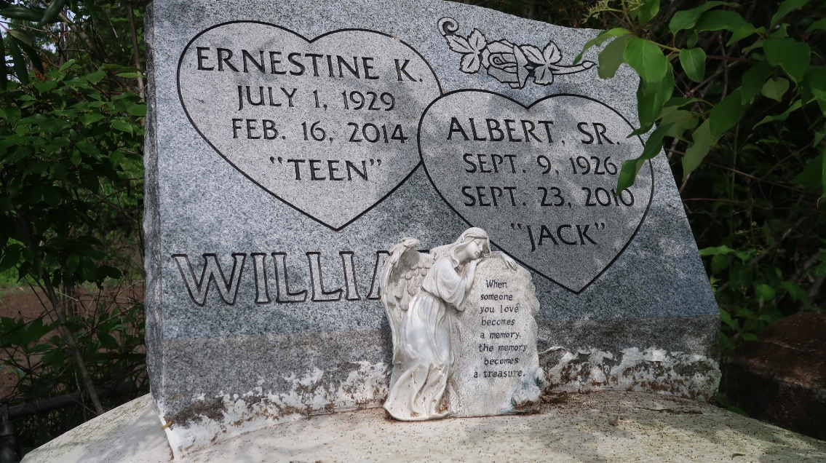

Ernestine Kirklin Williams, age 84, passed away on Sunday, February 16, 2014. Daughter of the late James and Fannie Kirklin, Wife of the late Albert Williams, Sr. Mother of Ernestine Albert, Glenda Williams, Patricia Joseph (Roger), Lisa (James) Williams, Melissa (Jimi) LeBlanc, Fannie (Lawrence) Bolden, Betsy (Cornell) Steptore, Katherine Clayton (Calvin), Sandra Williams, Albert (Rosalind) Williams, Jr., Shelton (Della) Williams and Robyn Gregoire Whom she reared as her own. And the late Carl, Michael, Michelle, and Rochelle Williams. Sister of Emmaline Washington, and Robert Kirklin. She's also survived by a host of Grandchildren, Great grandchildren, nieces, nephews, cousins, sisters in law, and friends.
Funeral services will be held on Saturday, February 22, 2014 at St. Matthew B.C., 3582 Hwy 44, Paulina, La., at 11:00am. Rev. Herman Clayton Pastor. Visitation will begin at 9:00am until services time (ONLY). Interment in Antioch Cemetery. Services Entrusted to Hobson Brown Funeral home 985-535-2516.

The Times-Picayune, New Orleans, Louisiana
Feb. 20 to Feb. 21, 2014

