Murray Williams Sr.
January 3, 1956 – September 30, 2010

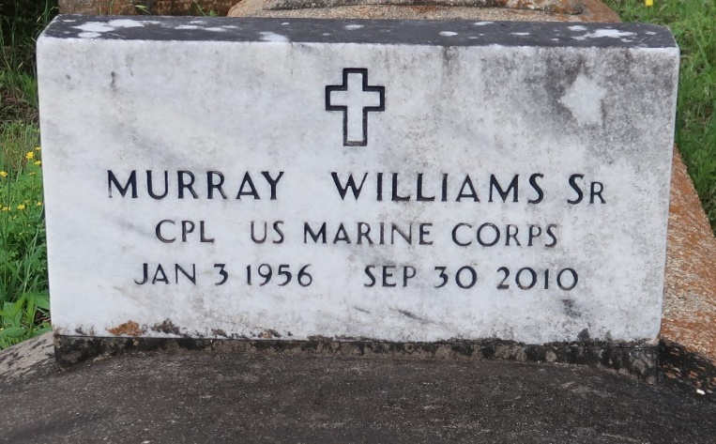

Murray Williams, Sr. at Tulane Medical Center, New Orleans, LA, at 3:15 a.m., Thursday, September 30, 2010. Son of Artemise Ezidore Williams and the late Marshall Williams, Sr. Husband of Cassandra Green Williams. Father and father-in-law of Chantell and Cody Long, Murray Jr. and Ranata Williams, Ricardo and Andria Williams, Marlon Washington and the late Calebra Washington. Brother and brother-in-law of Annie Lee and James Emery, Artemise and Joe Bernard, Stella and Larry James, Sidney and Jackie Williams, Randy and Judy Williams, Marshall Williams, Jr. and Norma and Larry Williams. Son-in-law of Rosa Lee Cooper and the late Adam Cooper, Sr. Brother-in-law of Dow and Terry Lynn Green and the late Debra Diggs. Also survived by 12 grandchildren, nieces, nephews, cousins, other relatives and friends. Age 54.
Visiting at First Community Antioch Baptist Church, Hwy. 3125, Lutcher, LA, Saturday, October 9, 2010 from 9:30 a.m. until Religious Services at 11:00 a.m. Conducted by the Rev. Ferdinand Gaines, Jr. Interment in Church Cemetery. BRAZIER-WATSON FUNERAL HOME in charge of arrangements.

The Times-Picayune, New Orleans, Louisiana
October 8, 2010

