Ralph Williams
September 15, 1953 – May 31, 2016

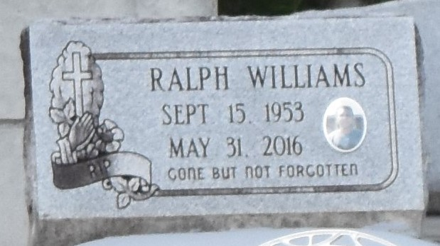

Ralph "Ralphie" Williams at the age of 62 yrs. departed this earthly life on Monday May 31, 2016 at his residence with his family at his side. Son of the late Sarah Bell Clark Williams and Joseph Williams Sr. Beloved husband of Claudia F. Williams of Paulina, La. Loving father of Jazare' Williams and Nicole Ferdinand. Brother of Bruce Williams (Linda), Abbielane Williams Bell, Joseph Williams Jr., Devaki Turner (Darryal), Tommy Williams (Darlene), and the late Tyrone Williams (Carolyn). Nephew of Velma Poche. Grandfather of Kaiden Creecy. Godfather of Neosha Williams and Ulysses Washington. Also survived by a host of nieces, nephews other relatives and friends. A native of Gramercy, La and a resident of Paulina, La.
Relatives and friends, Pastors, Officers and Members of New Zion Full Gospel Church of Gramercy, La and all neighboring churches are invited to attend the home going celebration on Saturday, June 4,2016 at 11:00am at New Zion Full Gospel Church, 216 W. Main St., Gramercy, La. Pastor Emil Dean Mitchell officiating. Interment in Antioch Cemetery of Paulina, La. Visitation will be from the above name church from 9:00am until service time. Bardell's Mortuary of Mt. Airy, La. in charge Information: 985-535-6837.

The Advocate, Baton Rouge, Louisiana
June 2 to June 4, 2016

