Tyrone Williams
November 23, 1951 – December 13, 2011

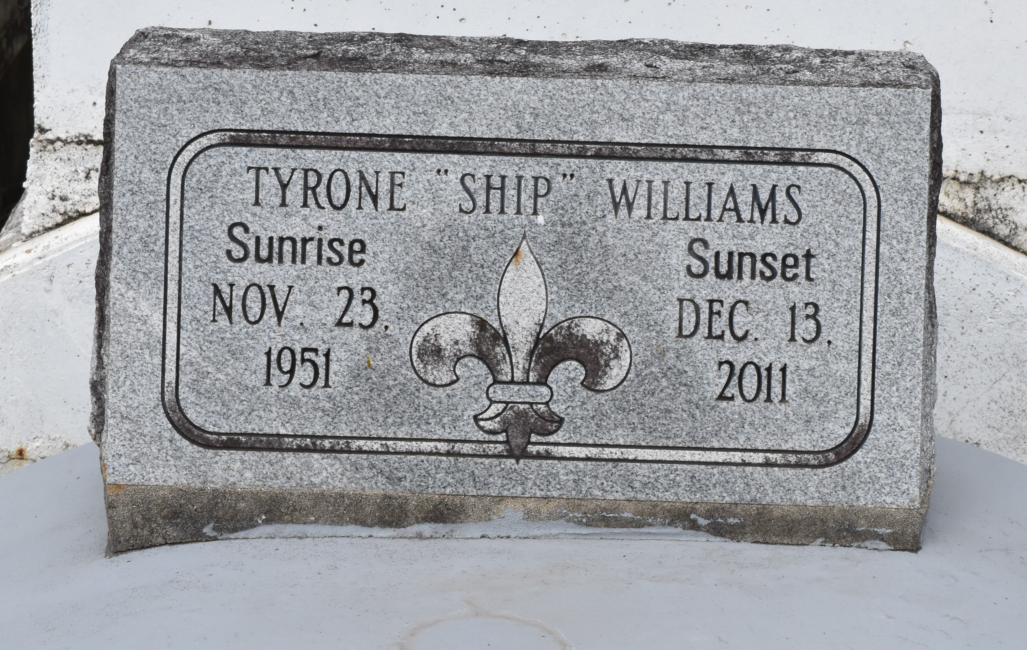

Tyrone "Ship" Williams, at Ochsner Foundation Hospital in Jefferson, LA., at 10:40 A.M., Tuesday, Dec. 13, 2011. Son of the late Joseph Williams, Sr., and Sarah Clark Williams. Husband of Carolyn Martin Williams. Father of Neosha Williams, companion Bryan, Devadus Williams, companion Carlton, Quanta Williams, companion Markquell, Tracie Whittington and husband Durell, Latanya Williams and Davern Williams and companion Katia. Brother of Devaki Robertson, Abbielane Bell, Ralph, Bruce, Tommy and Joseph Williams, Jr. Brother in law of Claudia, Linda, and Darlene Williams and the late James Robertson and Gregory Bell. Also survived by 15 grandchildren, numerous nieces, nephews, cousins, aunts, uncles, other relatives and friends. Age 60. Visiting at New Zion Christian Center, Gramercy, Saturday, Dec. 17, 2011 from 9:30 A.M. until religious services at 11:00 A.M. Conducted by the Rev. Emil D. Mitchell. Interment in Antioch Cemetery, Paulina, LA. Brazier-Watson Funeral Home in charge of arrangements.

The Times-Picayune, New Orleans, Louisia
Dec. 15 to Dec. 16, 2011

