Willie Mae (Martin) Burns
March 25, 1928 – October 17, 2015

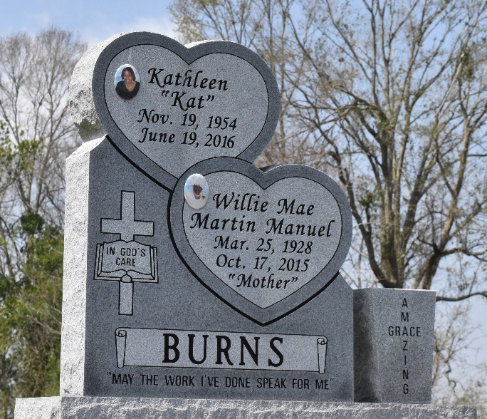

Willie Mae "Mother" Burns at the age of 87 years departed this earthly life and entered into eternal rest on Saturday October 17, 2015 surrounded by her family.
Daughter of the late Adam and Mary Martin. Loving mother of Barry (Earline) Manuel of Winterhaven, Fl., John (Donna) Burns Jr. of Gonzales, La, Frank (Cassandra) Burns of Garyville, La., Micheal (Debra) Burns of Nashville, Tn., Adam Burns of Chicago, Il., Joyce (Harvey) Smith of Lutcher, La., Linda Hayes, Debra Hill of Lutcher, La., Kathleen Burns of Gramercy, La., Loretta Joseph of Westwego, La., also survived by one brother Morris Martin of Lutcher, La. 57 grandchildren, 112 great-grandchildren, 10 great-great-grandchildren. A host of nieces, nephews other relatives and friends. A devoted friend Stella Jenkins.
She was preceded in death by her parents Adam and Mary Foster Martin, 1st husband Alexander Manuel Sr., 2nd husband John W. Burns Sr., children: Alexander Manuel Jr. and Everett C. Burns, Step-children: Sherry Robinson and Dorothy Jean Harris, siblings: Clarence, Ernest, Gloston, Leon, Lawrence and Philip Martin, grandchildren: Alexander Manuel III, Latasha Manuel and Frank Anthony Burns.
Pastors, Officers and Members of Greater King Triumph Baptist Church, First Community Antioch Baptist Church, Beacon Light Baptist Church, Rising Star Baptist Church, Christian Assembly, Lutcher Senior Center and all neighboring churches are invited to attend the home-going celebration on Thursday, October 29, 2015, at 11:00am at the First Community Antioch Baptist Church, 10860 Hwy. 3125, Lutcher, La., where the host Pastor is Rev. Ferdinand Gaines Jr.; Pastor Jarrow is officiating. Interment in Antioch Cemetery of Paulina, La. Visitation will be from 9:00am until service time at The First Community Baptist Church. Bardell's Mortuary of Mt. Airy, La. in charge. Information: 985-535-6837.

The Advocate, Baton Rouge, Louisiana
Oct. 27 to Oct. 29, 2015

