Rodney Clayton, Sr.
September 22, 1950 - May 14, 2023

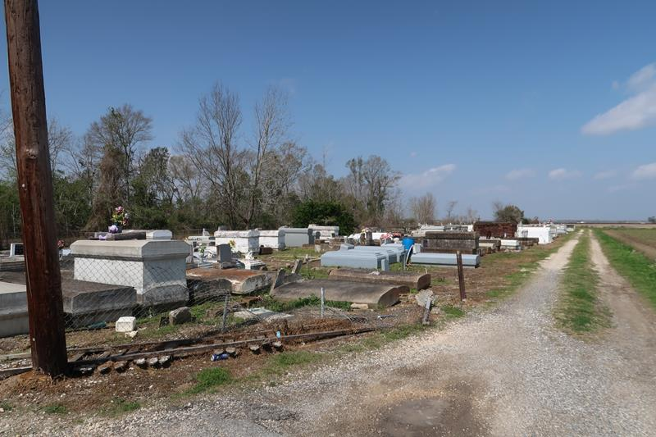

During the early hours of Sunday, May 14, 2023, Rodney moved to his eternal home after battling an illness.
Rodney "Flash" Clayton, Sr. was born on September 22, 1950, to the late Ernest and Lousier Clayton. He grew up in Paulina, LA with his siblings and enjoyed spending time with them down Bend Lane. He accepted Christ and was baptized by the late Pastor Aaron Shade at Evergreen Baptist Church. He remained a faithful member of Evergreen under the pastoral ship of Rev. Nolan Albert. Rodney attended St. Martinville Elementary and Junior High schools. In 1968, he graduated from Cypress Grove High school. After graduating, Rodney began working for St. James Parish in the Maintenance Department. He decided he wanted to become a police officer. During his tenure there, he earned the nicknames "Boss" and "Bossman." Rodney worked for St. James Parish and St. James Parish Sheriff Office from February 12, 1976, until his retirement on May 1, 2006. During his tenure, he served as a Patrol Officer, Corrections Officer, Lieutenant, and retired as the Assistant Warden.
In June 1989, Rodney was joined in holy matrimony to Jerry Mae Jackson. They were blessed with five children: the late Charlton Owen Jackson, Dannisha Danette, Dominique Lashanda, Rodney II, and Gabrielle JaShonda Clayton.
In his spare time, you could find him out working in his yard, gathering with his classmates, or visiting his sisters and friends. He enjoyed watching wrestling, basketball, and football. He looked forward to watching the Saints and his great-nephew Jarvis playing.
Rodney is preceded in death by his wife, Jerry Mae Jackson Clayton, son, Charlton Jackson, parents, Ernest and Lousier Clayton, brothers, Ernest Clayton, Jr. and Perry Clayton, sisters, Janet Clinton and Elouise Turner and sister-in-law, Geraldine Ursin. His precious memories will be forever cherished by his children, Dannisha, Rodney II, and Gabrielle of Paulina, LA and Dominique of Springfield, VA; granddaughter, Darrien Bolding and great-grandsons, Jeremiah and Jua'Kedrick Fleming of Baton Rouge, LA; siblings, Ernestine Alexander of Gramercy, LA, Joyce Clayton of Paulina, LA, Floyd (Shawn) Clayton of Oklahoma City, OK, and Michael (Marie) Clayton of LaPlace, LA; brother-in-law, James Clinton of Gonzales, LA, and Uncle, John Clayton of Paulina, LA. He will be missed by a host of nieces, nephews, cousins, other relatives, Godchild, and friends.
Family and friends are invited to the homegoing celebration on Monday, May 22, 2023, at 11 am at Evergreen Baptist Church, 3399 Hwy 3125, Paulina, LA. Viewing from 9 am until service time. Interment: Antioch Cemetery, Paulina, LA. Visitation will be held Sunday, May 21, 2023, from 3 pm – 6 pm at Bardell's Mortuary, 3856 LA 44, Mt. Airy, LA.
The Advocate, Baton Rouge, Louisiana
May 21, 2023

