Curley Curt Parker
February 15, 1926 – October 1, 2001

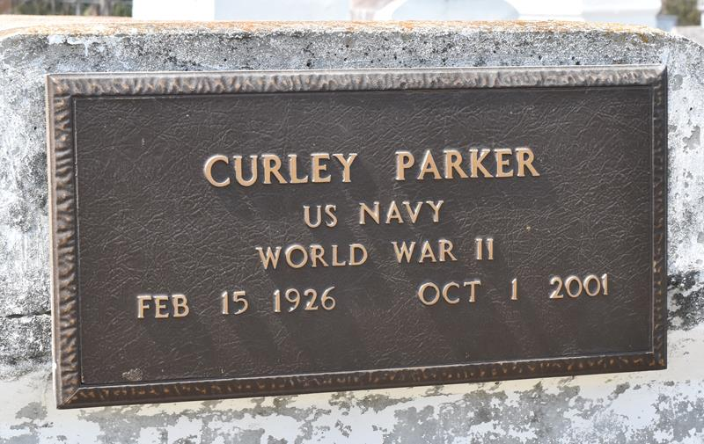

Curley "Curt" Parker, a retired worker for the Louisiana Department of Transportation and Development, died Oct. 1 of a heart attack at River Parishes Hospital. He was 75. Mr. Parker was born in Fayette, Miss., and lived in Paulina. He served in the Navy.
Survivors include four sons, Michael and Stephone Parker, Curly Parker Jr. and Alvin Williams; two daughters, Stella Johnson and Robyn Gregoire; 11 grandchildren; and six great-grandchildren.
A service will be held Saturday at 11 a.m. at St. Matthew Baptist Church, 3582 Louisiana 44 in Paulina. Visitation will begin at 9 a.m. Burial will be in Antioch Cemetery in Paulina.
Hobson Brown Funeral Home is in charge of the arrangements.

Times-Picayune, The (New Orleans, Louisiana)
Friday, October 5, 2001
**

PAULINA - Curley "Curt" Parker, 75, a native of Fayette, Miss., and resident of Paulina for many years, died Oct. 1.
He was the husband of the late Clara Kirklin Parker and father of Stella Johnson, Robyn Gregoire, Alvin Williams and Michael, Stephone and Curley Parker Jr. He was the son of the late Will and Lucille Parker Green and the brother of four brothers and two sisters. He is survived by 11 grandchildren and five great-grandchildren.
Services are today at 11 a.m. at St. Matthew Baptist Church, Paulina, with interment at Antioch Cemetery, Paulina. Visitation starts at 9 a.m.

L'Observateur (La Place, Louisiana)
Tuesday, October 9, 2001

