Beatrice (Weber) Perkins
October 7, 1927 – September 13, 2002

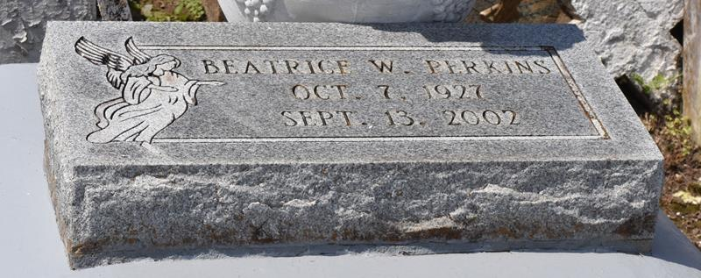

Resident of Gramercy, LA. She was preceded in death by her parents, Joseph and Georgina Weber; husband, Johnnie Perkins; and siblings, Melvina Baker and Joseph Weber, Jr., Oscar Weber, Sr., John Weber, Anderson Weber, Clementine Weber and Celea Weber.

She is survived by her children, George Weber, Sr., Jerry Perkins, Sr., Johnnie Mae Armont, and Beatrice Mitchell; sister, Julia Joseph; ten grandchildren and six great grandchildren.

Unknown source

