Alex Scott Sr.
July 25, 1928 – March 27, 1998

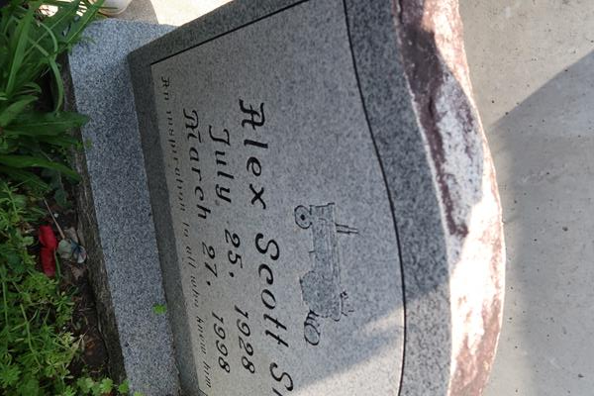

U.S., Social Security Applications and Claims Index, 1936-2007

Name Alex Scott
Gender Male
Race Black
Birth Date 26 Jun 1928
Birth Place Ramey St Jam, Louisiana
Death Date 15 Mar 1998
Father Edward Scott
Mother Odea Ward
SSN xxx
Notes Jul 1944: Name listed as ALEX SCOTT
**

Alex Scott from tree Scott/Kirklin/Smith Family Tree

Birth 27 Jun 1928 Louisiana, USA
Death 1998 Paulina, St James, Louisiana, USA
Father Edward Scott
Mother Odea Ward
100 People 2 Records 2 Sources

