Trashira Janiece Ursin
January 31, 1985 – May 25, 2001

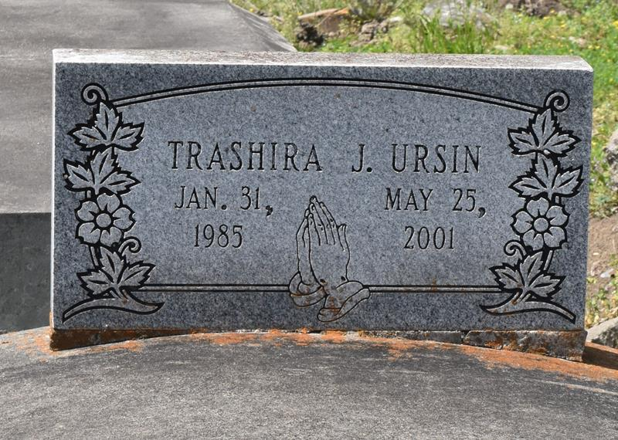

Trashira Janiece Ursin, a student, died Friday from injuries sustained in a car accident in Bristol, Tenn. She was 16. Ms. Ursin was born in New Orleans and lived in Woodville, Miss., for 13 years. She attended Wilkinson County High School in Woodville and was a member of Morning Star Baptist Church in Woodville. Survivors include her father, Johnny Jackson Jr.; her grandparents, Johnny Jackson Sr. and Lydia Jackson; three brothers, Ricou, Travis and Calvin Ursin, all of Woodville; and a sister, Carisa Ursin, of Alexandria, Va. A funeral will be held Friday at 7 p.m. at Wilkinson County High School in Woodville. A dismissal service will be held Saturday at 11 a.m. at Evergreen Baptist Church in Paulina. Burial will be in Antioch Cemetery in Paulina. Bardell's Mortuary is in charge of arrangements.

The Times-Picayune (New Orleans, LA)
Thursday, May 31, 2001
Contributed by Jane Edson
**

PAULINA – Trashira J. Ursin, 16, a resident of Paulina, died May 25 in an automobile accident in Bristol, Tenn. She was the daughter of Johnny Jackson and the late Geraldine Ursin and sister of Carisa, Ricou J., Travis, Calvin and the late Frederick Ursin. Dismissal services are today at 11 a.m. at Evergreen Baptist Church, Paulina, with interment at Antioch Cemetery, Paulina.

L’Observateur, La Place, Louisiana
June 2, 2001

