Joyce Marie Ross
October 10, 1961 – November 30, 2013

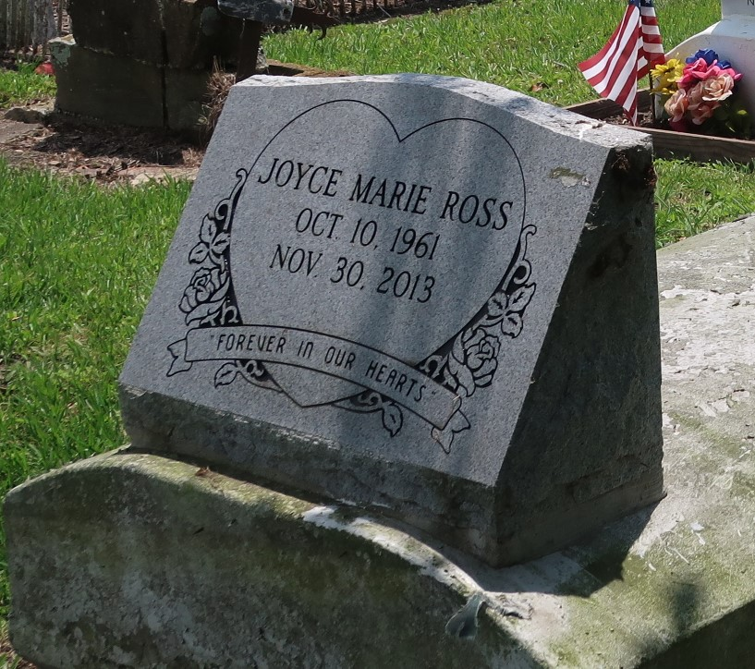

Joyce Marie "JC" Ross native and resident of St. James, passed away on Saturday, November 30, 2013, at 5:20 a.m. at Our Lady of the Lake Regional Medical Center in Baton Rouge. She was 52.
Visiting at Buena Vista Baptist Church, St. James, religious services, Conducted by the Rev. Joseph Coleman. Interment in church cemetery.
Survived by her mother, Samelia Joseph Ross; her daughter, Shantae Ross and her son, Darion Ross; her sister, Margaret Lewis, and brothers, Wilbert, Ross Jr., and Davis Ross and wife, Sandra; four grandchildren; two aunts; two uncles; nieces, nephews, cousins, other relatives and friends.
Preceded in death by her father, Wilbert Ross Sr.; a daughter, Chalera Ross; and a brother, Arthur Ross.
Brazier-Watson Funeral Home in charge of arrangements.
The Advocate, Baton Rouge, Louisiana
December 5 to December 6, 2013

