Norman Armant
December 8, 1938 - July 10, 2019

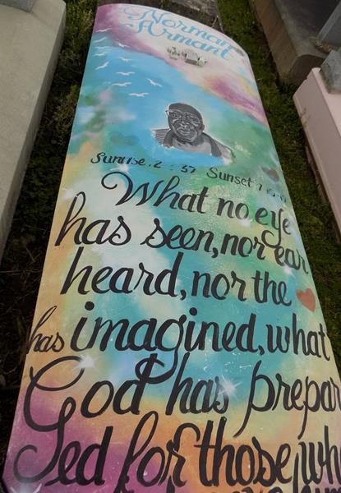

On Wednesday, July 10, 2019 at 7:30 am our loved one was plucked from our family garden. God called our beloved Norman Armant Sr, from labor to his heavenly reward. Norman was born December 8, 1937 to the union of Jules Armant Sr, and Nettie Armant; of Vacherie, LA. Norman knew God and accepted Christ as his personal savior. He was baptized in the mighty Mississippi River during the Grand Baptism on Easter Sunday of 1963 by the late Rev. Maxwell Cage. He was avid listener of gospel music and enjoyed watching cartoons and sci-fi movies. Norman was a member of The Young Souldier Club. Norman joined in holy matrimony to the love of his life Ms. Irma Marie Morris. To this union 11 children were born. Norman leaves to cherish his memories 9 children. Norman Armant Jr. (Faye), Eureka Stemley (Dwayne), Dwayne Armant (Kim), Christine Joseph (Rodney), Alicson Armstrong (Bryan), Hilton, Melissa, Montrelle and Paula Armant. One sister Jerry Lee Williams and one brother Joseph Armant Jr. 2 sisters-in-law Mildred Armant and Helen Bazile, one brother-in-law; Roland Morris Jr (Wanda). 28 grandchildren, 27 great grandchildren, a devoted friend Hayward Batiste and a host of nieces, nephews, other relatives, and friends.
He was proceeded in death by parents Jules and Nettie Armant. Daughters Robin Ann and Osmond Armant. (2) Sisters Rose Lee Williams and Idelma Ross, (2) Brothers Clarence Bazile and Curb Armant Sr. and one niece Dorine Smith.
All neighboring communities and churches are invited to join the family for a Homegoing Celebration at First Baptist Church, 1244 Magnolia Heights St, Vacherie, LA 70090 on Saturday July 20, 2019 at 11am, Pastor Johnnie B. Magee, Jr officiating. Visitation at 9am until service time. Interment at First Baptist Church Cemetery.

Treasures of Life Funeral Services, Gramercy, Louisiana

