Mary Louise (Stewart) Batiste
October 27, 1919 – May 26, 1995
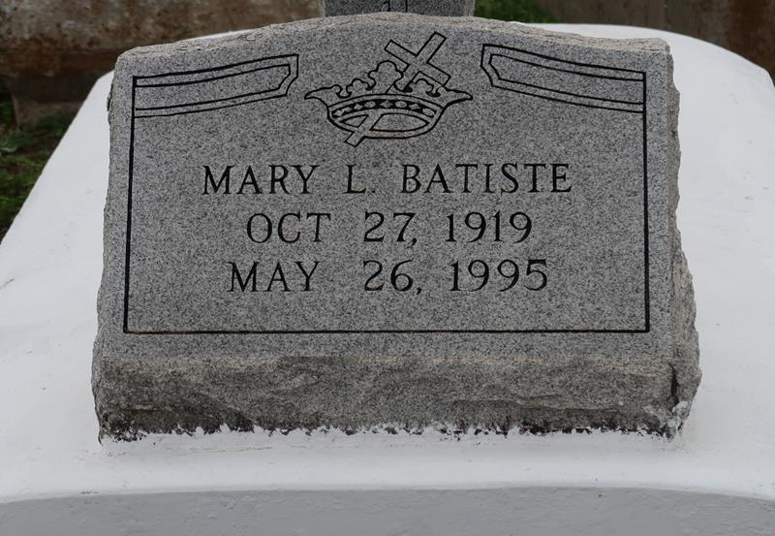

A funeral is scheduled for 11 a.m. Wednesday at Highway Baptist Church in Vacherie for Mary Louise Stewart Batiste, 75, a native and resident of Vacherie, who died at 7:15 p.m. Friday, May 26.1995
Visitation will be 8 a.m. to funeral time Wednesday at the church. Burial will be in the First Baptist Church Cemetery.
She was the wife of Robert Batiste Jr.; mother of Odessa Nathan and Earl, Lionel, Peter and the Rev. Nathaniel Batiste, all of Vacherie, the Rev. Robert Batiste III of Thibodaux, LaVerne Dennis of St. James, Florestine Kent of Riverside, Calif., the Rev. Herman Batiste of Houston, Albert Batiste of LaPlace and Warren Batiste of Ponchatoula.
She is also survived by 68 grandchildren, 21 great-grandchildren, four brothers and a sister.
She was preceded in death by her parents Sherman and Sarah Stewart; two sisters; three brothers; a grandchild; and a great-grandchild.
Earl Baloney Funeral Home of Garyville is in charge of arrangements.

Unknown source

