Rose Mae (Fletcher) Best
May 7, 1949 – February 17, 2025

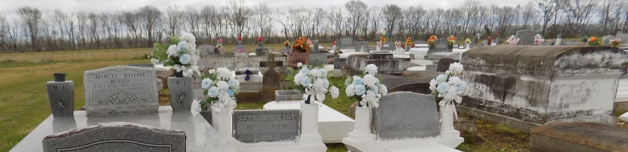

Rose Best was born on May 7, 1949, in Vacherie, Louisiana. She was the third of ten siblings born to the late Harold and Louella Williams Fletcher Sr. She was raised on the Laura Plantation located on the west bank of the Mississippi River in Vacherie.
A Time to Plant: Rose accepted Christ in 1961 and was baptized in the Mississippi River by the late Reverend Author Jones of First Baptist Church. She attended public school in Vacherie, LA, and graduated from Magnolia High School in 1967. Growing up in Vacherie, she was affectionately known as “Tubby”. She later attended various colleges and earned an Associate’s Degree in Finance.
A Time to Love: Rose was united in marriage to Oliver Antoine Sr. in 1967, and from this union, they were blessed with a son, Oliver Antoine Jr. She was later married to William Best, and from this union, they were blessed with a daughter, Joy Lynn Best.
A Time to Build: Rose began her career with the Federal Government in 1980. She had a successful career as a Budget Analyst, which allowed her to travel both domestically and internationally. Rose was a dedicated employee who deeply valued supporting the men and women of the United States Armed Forces. Throughout her career, she received several prestigious awards, including recognition for 26 years of Government Service. However, the one she cherished the most was the medal she received for saving someone’s life.
A Time to Mourn: Rose faced the profound loss of her closest loved ones in the later years of her life, yet she persevered through her steadfast faith in God and the unwavering support of those around her. A Time to Give: In her later years, Rose enjoyed spending time with family and friends, supporting church activities, traveling, casinos, and attending social gatherings. She had a special love for meeting new people and believed she never met a stranger. Her love for family was evident in everything she did. Much like Mother Teresa, she embodied a spirit of generosity, giving selflessly to those in need. Whether offering financial help, a place to stay, or simply a listening ear, she touched countless lives. One of her favorite sayings was, “Pass it on”.
Rose leaves behind a legacy of caring for others. A Family Left to Cherish her Memories: Siblings: James (Debra) Fletcher of Lorton, VA, Harold (Shirley) Fletcher Jr. of Suitland, MD, Elton (Ellen) Fletcher Sr. of Johns Creek, GA, Anthony (Naomi) Fletcher Sr., and Marlis (Christine) Fletcher both of Vacherie, LA; Aunt: Gloria Butler; Brother in Law: George Joseph; God Daughter: Mikita Fletcher and a host of nieces, nephews, cousins, and friends.
She was preceded in death by her Husband: William Best; Son: Oliver Antoine Jr.; Daughter: Joy Lynn Best; Parents: Harold Fletcher Sr. and Louella Williams Fletcher; Maternal Grandparents: Beulah Butler and Freddie Butler; Paternal Grandparents: James Fletcher Sr. and Bertha Fletcher; Sisters: Julia Joseph, Claudia Steward and Jacqueline Oubre; and Brother: Allen “Rocky” Fletcher. Many loved ones have gone before her, and now, by God’s grace, she joins them in rejoicing with the saints in heaven, singing praises, and awaiting the day when her family will reunite for a heavenly banquet. Rose lived her life as her namesake “She was a Rose, and she was the Best.”
A celebration honoring her life and legacy will be held on Saturday, March 1, 2025, at First Baptist Church, 1244 Magnolia Heights St., Vacherie, LA for 11 A.M. Visitation begins at 9 A.M. Internment to follow at First Baptist Church Cemetery, Church St., Vacherie, LA.

Treasures of Life Funeral Services, Gramercy, Louisiana
Thursday, February 28, 2025

