Leonard J. Brown
August 22, 1953 - August 21, 2009

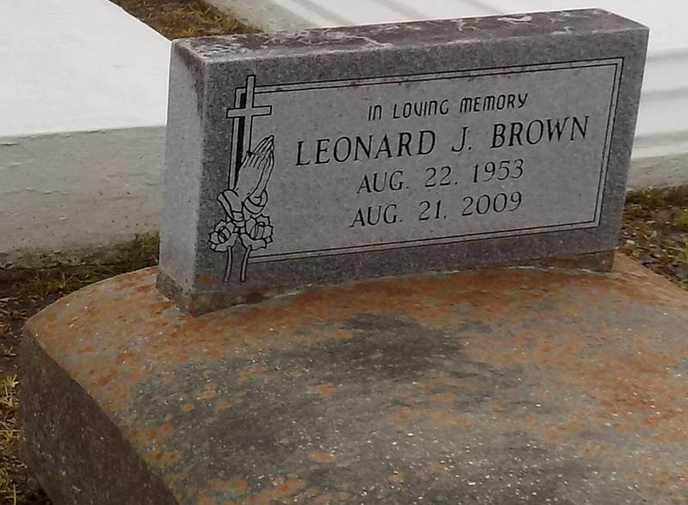

Leonard J. Brown, of Vacherie, LA, on Friday, August 21, 2009 at his residence departed this life. Son of Irvin J. Brown, Sr. and the late Ruth Noel Brown. Father of Kaneesha Brown. Grandfather of Aubrey. Brother of Gregory and Grayling R. Brown, Marsha Fleming, Jane Butler, the late Irvin J. Brown, Jr. and Lena Brown Dupard. Also survived by aunts, uncles, nieces, nephews, cousins, and friends. A native and resident of Vacherie, LA. Age 55 years.
Relatives and friends of the family, also pastors, officers and members of the First Baptist Church, Highway B.C., Children of Israel B.C. and neighboring church are invited to attend the Funeral Services on Friday, August 28, 2009 at 11:00 a.m. from the First Baptist Church, 1244 Magnolia Heights, Vacherie, LA. Rev. Johnnie Magee, officiating. Interment Church Cemetery. Visitation at the Church after 9:00 a.m. on Friday,
The Baloney Funeral Home, LLC, 399 Earl Baloney Dr., Garyville, LA; Information: (985) 535-2540 In Charge of Arrangements.

Times-Picayune, The (New Orleans, LA) - Thursday, August 27, 2009
Contributed by Jane Edson

