Alfred Butler, Sr.
July 31, 1935 – July 12, 2001

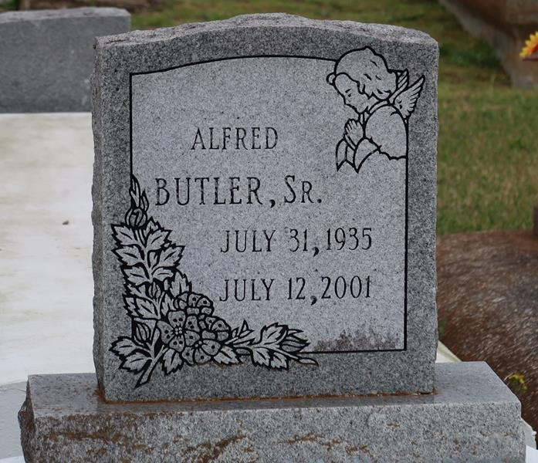

BUTLER
VACHERIE - Alfred "Pop" Butler Sr., 65, a native and resident of Vacherie, died July 12. He was the father of Angela Lucas, Melanie Francois, Alfred Butler Jr. No. 1 and Alfred Butler No. 2. He was the brother of Doris Stewart, Florida Simoneaux and Gloria Butler. He is survived by nine grandchildren. He was the companion of Gloria Braxton.
Services are today at 11 a.m. at First Baptist Church, Vacherie, with interment at the church cemetery. Visitation starts at 9 a.m.
L’Observateur, LaPlace, Louisiana
July 18, 2001

