Alden Costley
October 31, 1959 – September 14, 2024

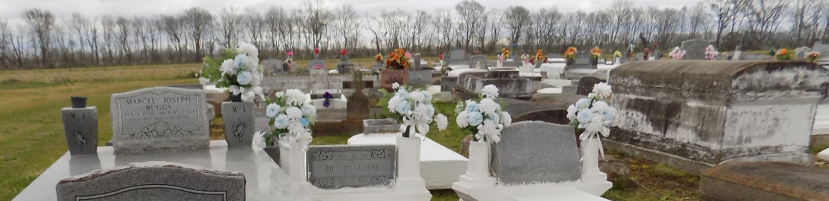

It is with great sadness that the Costley family announces the passing of Big Al on September 14, 2024, at Our Lady of Lake Hospital Baton Bouge, LA. Age 64 years.
Big Al was born in New Orleans, Louisiana to Robert, Sr and Louisa Costley on October 31, 1959. Big Al leaves to cherish his memory with his life partner Elouise Gale, his children Shellbye Francis (Leo), LaToya Francis and Alex Gale. Four sisters: Genella (John) Miller, Marsha (Roy) Jones, Gail C. Williams and Natalie (Clarence) Davontine: four brothers, Robert Jr. (Althea) Costly, Andrew, Sr. (Cynthia), Stanley Dumas and Terryel, Sr. (Jacqueline) Benoit; two aunts Dorothy Lewis and Grace Nailor; and a host of loving nieces, nephews, cousins and friends.
His celebration of life and legacy will be held on Saturday, September 28, 2024 at First Baptist Church of Vacherie, 1244 Magnolia Heights St, Vacherie, LA. 70090. Visitation begins for 9am followed by Celebration o Life service for 11am. Dr Johnnie B Magee Jr., Host Pastor, Rev Dr Leonard L. Favorite, Sr .officiating. Interment First Baptist Church cemetery.

Treasures of Life Funeral Services, Gramercy, Louisiana

