John Lawrence Emery
May 7, 1950 – May 11, 1969
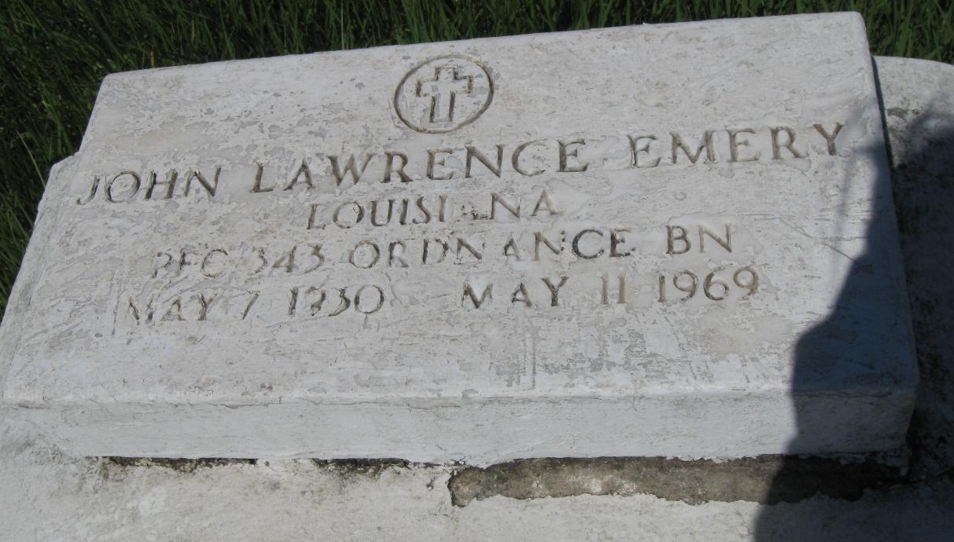
Phot by rw2009

EMERY

John L. Emery, of Vacherie, La., on Sunday, May 11, 1969, at 5:00 o’clock a.m., beloved son of Mrs. Sarah Emery and the late Rev. Washington Emery; brother of Mrs. Leona Williams, Mrs. Wilamena Armant and James Emery of Vacherie, La., Mrs. Pearl Brown, Louisa Butler, Rosie Smith and Joseph Emery of New Orleans, La.; also survived by 2 aunts, and a host of nieces, nephews, other relatives and friends; a native, and a resident of Vacherie, La.
Relatives and friends of the family, also paster, officers and members of the highway Baptist Church, First Baptist Church, Pilgrim Baptist Church and Magnolia Benevolent Society of Vacherie, La., St. James Parish Teachers Association, St. James Parish School Board, employees of John Mansville, Marrero, La., Elysion Convalescent Home, New Orleans, La., are invited to attend the funeral.
Services from the Highway Baptist Church, Vacherie, La., on Wednesday, May 14, 1969 at 12 o’clock noon. Rev. James Trench officiating. Interment in church cemetery. Wake services Tuesday night, May 13, 1969, at the above named church. Earl Balony and Sons, Edgard, La., in charge.

Times-Picayune, New Orleans, Louisiana
Tuesday, May 13, 1969, p. 12

