Mildred (Luke) Harris
June 3, 1930 – January 18, 2007

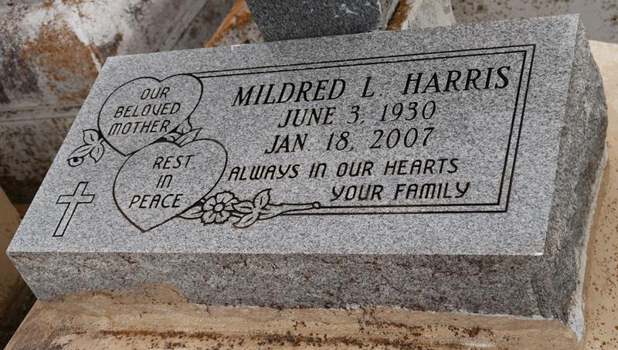

Mildred Luke Harris, at age 76, was called home on the evening of Thursday, January 18, 2007. Victory over shadowed the pain as she entered into her new home of rest. Wife of the late Wilbert Harris, Sr. She leaves to cherish her precious memories children: Linda Luke (Thomas) Hilton of Vacherie, LA, Betty Perkins - Lutcher, LA, Joan H. Palmer - Huntsville, AL, Yvette (George) Harrison - Gonzales, LA, Rosa (Gregory Sr.) - Vacherie, LA, Joan (Dameion) Tureaud - Gramercy, LA, Wilbert (Rose) Harris, Jr., Bruce (Joyce) Harris, Sandy (Sonya) Harris, Allen J. Harris, Gregory Price, Jr.; and sister, Gloria Collins all of Vacherie, LA. She is survived by 5 generations of grandchildren (110); a host of nieces, nephews, cousins and friends. Mildred was a life long resident of Vacherie, LA. The Homegoing Celebration will take place on Wednesday, January 24, 2007 at 11:00 a.m. at the First Baptist Chuuch, 1244 Magnolia Heights, Vacherie, LA. Visitation will be held that morning. Family and friends are invited to join the celebration. Arrangements by D.W. RHODES FUNERAL HOME.

The Times-Picayune, New Orleans, Louisiana
January 24, 2007.

