Howard Joseph Jr.
April 5, 1952 – March 31, 2010

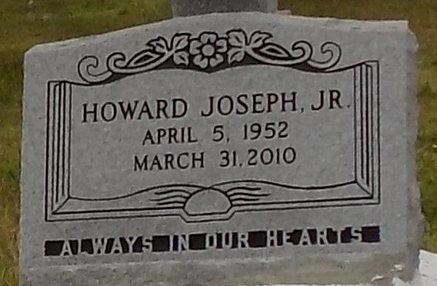

On Wednesday, March 31, 2010 Howard "Hicky" Joseph, Jr. entered into eternal rest. He was 57. Mr. Howard was a native of Vacherie, LA and a resident of Shreveport, LA. He leaves to cherish his memories, 5 children, 1 grandchild, 3 sisters, 2 brothers and a host of nieces, nephews, other relatives and friends.
Relatives and friends of the family are invited to attend the funeral service on Saturday, April 10, 2010 at 1:00am at First Baptist Church, 1244 Magnolia Heights, Vacherie, LA. Visitation 9:00am to 11:00am. Rev. Johnnie Magee-officiating. Interment First Baptist Church Cemetery, Vacherie, LA.
Arrangement by Rhodes United Fidelity Funeral Home, 2929 Scenic Hwy, Baton Rouge, LA. Please log on to www.rhodesfuneral.com to sign guest book.
The Times-Picayune, New Orleans, Louisiana
April 9, 2010

