Shelia Ann (Morris) Landrum
November 4, 1953 – November 28, 2024

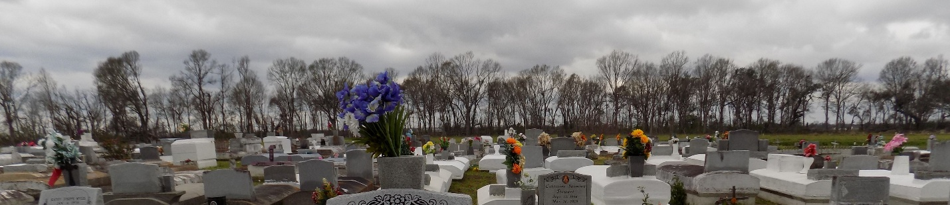

We celebrate the life of our mother Shelia Ann Morris Landrum. Shelia was released from sickness and pain, and went on to be with her Father in heaven on Thanksgiving morning, November 28, 2024.
Shelia was born on November 4, 1953 to Thelma “Sal” Morris and Clarence “Belton” Morris, her father who died just weeks before she was born. Her sister Lena Mae was also a key parental figure in her life. In 1963 Shelia was baptized in the chilly waters of the Mississippi by Reverend Maxwell Cage of First Baptist Church in Vacherie. She served the Lord by serving people in helps ministries including Pastor’s Aid and kitchen/culinary service. Her love of music was reflected in her choir membership in every church she called home, including her final church home at Second Highway Baptist Church in Marrero. Shelia spent her last days listening and singing along to gospel classics.
Shelia was an excellent cook and her delicious meals were her primary way of saying “I love you” and “I’m sorry”. Shelia valued an orderly space and spent much of her free time cleaning for family, friends, and church members – making houses feel more like home. Shelia was married to her high school sweetheart, the late Gregory Brown, Sr. on July 17, 1971. Together they had a child, Gregory Brown, Jr. After the dissolution of this marriage, Shelia left Vacherie and moved to Avondale. There she eventually married her beloved husband George Landrum. George and Shelia were married on July 18, 1981. To this union were born Irna and Brian Landrum. Together they raised all three adventurous, and frequently well-behaved, children. It tickled Shelia to scandalize her children by reminding them that all her days weren’t spent in church. She would demonstrate dances from her youth as well as shock them with her ability to mimic the dances from early 90s New Orleans bounce music. In 2011, Shelia became a grandmother with the birth of DeAnna, followed by Blair in 2013. Despite making fun of other grandparents for “letting them grandbabies make a fool” of them, she spent the next thirteen years enthralled with her grandchildren, bending to their whims and completely throwing out the rule book by which she raised her children. Her stubbornness was no match for their utter cuteness and sweetness.
She might not have had the strength to deny those girls anything, but no one can deny the strength it took to be a young widow, face down cancer (twice), heart disease, and kidney disease. Her raw defiance helped her beat the odds set against her for a long time. Unfortunately she could not fight the odds forever. Shelia spent her final days preparing the meal of a lifetime and insisted that we all eat together whether she was there or not. Because of her planning, family and friends were gathered together over warm food, comforting one another in fresh grief on Thanksgiving Day.
Shelia’s story will be carried forward by her children: Gregory (LaSharie) Brown, Irna (Nicci) Landrum, Brian (LaShonda) Landrum, and Beverly Heno whom she claimed as her own. Her legacy lives on in her granddaughters: DeAnna who shares her servant heart and Blair who shares her blunt pragmatism. Her history is lovingly held by her siblings Lena Ketchens, Chester Joseph, David (Valerie) Stewart, and Sonja Jones. She leaves behind a host of nieces, nephews, godchildren, cousins, in-laws, friends, and a couple frenemies.
She was preceded in death by her father Clarence Morris, mother Thelma Morris, husband George Landrum, brother O'Neal Stewart, and niece Rhonva Jackson.
The family invites you to celebrate Shelia's memory, at Treasures of Life Funeral Services, 315 E. Airline Hwy., Gramercy, LA 70052 on Friday, December 6, 2024. Viewing will begin for 12:00 noon followed by a memorial service for 1:00 p.m. Interment First Baptist Church Cemetery, Vacherie, LA. 70090.

Treasures of Life Funeral Services, Gramercy, Louisiana

