Dorothy (Thomas-Dumas) Lewis
April 25, 1931 - July 4, 2025

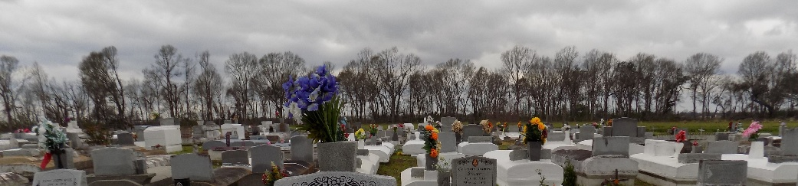

Dorothy T. Lewis ("Mother", "Momo") a native of Vacherie, LA, peacefully slept away on Friday, July 4, 2025 with family by her side. Dorothy was 94 years old when she departed this life and transitioned to her heavenly home. Mother accepted Jesus Christ at a young age and was baptized at First Baptist Church by Rev. Arthur Jones in the Mississippi River. She remained a member of First Baptist Church until her death. Momo was a loving mother, grandmother and great grandmother that would go over and beyond for her family and friends.
Mother leaves to cherish her memory, five children: Cora Lewis, Frank Thomas, Sr. (Trenice), Rose Lee Lewis, Diane Broden, Everlina Lewis (Willie); one sister, Grace Nailor; 37 grandkids; 71 great-grandkids, 22 great-great-grandkids; one goddaughter, O'Layja Noble and a host of nieces, nephews, cousins, and friends.
Momo was preceded in death by her husband, Clarence Lewis, Sr.; children, Gaylord Lewis, Eddie Lewis, and Barbara Thomas; parents, Mary Jones Dumas and Edward Thomas; sisters, Louisia Costly, Rose Harris, Theresa Alexander, Ruth Favorite, Cecile Rapp, Everlina Dumas, Pearl Celestine, Clara Thomas and brother, James Dumas and John Thomas, Sr.; and one son-in-law, Roland Broden, Sr.
A Celebration of Life will be held on Saturday, July 12, 2025 at First Baptist Church,1244 Magnolia Heights, Vacherie, La. 70090, for 11am; visitation will be held from 9am until service time. Interment First Baptist Church Cemetery.

Treasures of Life Funeral Services, Gramercy, Louisiana
July 13, 2025

