Linda (Luke) Hilton
September 16, 1947 – January 15, 2012

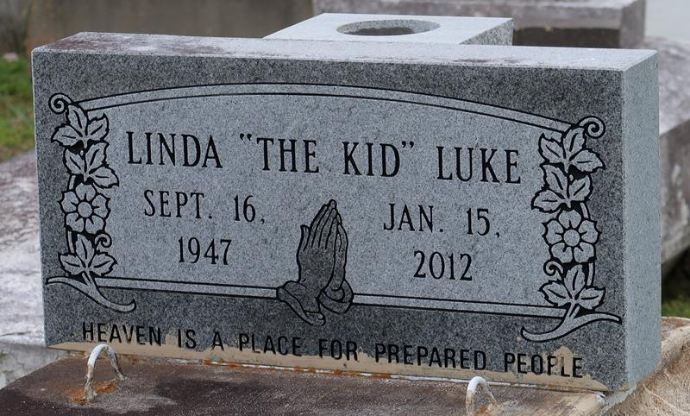

Linda Luke "The Kid" Hilton departed this life on Sunday, January 15, 2012. Daughter of the late Ernest Smith and Mildred Luke Harris. Mother of Mildred, Lolisa, Andre and Wilfred Stewart. Sister of Betty Perkins, Dr. Joan Palmer, Yvette Harrison, Rosa Price, Catherine Williams, Lolita Ambrose, Sandra Jean Thomas, Illona Smith, Bruce, Allen and Wilbert Harris, Newell and Reginald Smith. Also survived by 16 grandchildren, 3 great-grandchildren and a host of nieces, nephews, cousins, other relatives and friends.
Relatives and friends of the family are invited to attend the Funeral Service at First Baptist Church, Vacherie, LA on Saturday, January 21, 2012 at 11:00 am. Visitation will begin at 9:00 am. Interment: Church Cemetery. Arrangements by DW Rhodes Funeral Home, 1020 Virgil St. Gretna, LA. Please visit www.rhodesfuneral.com to sign the guest book.

Times-Picayune, The (New Orleans, LA)
Friday, January 20, 2012

