Dinah Jean (Zeno) Magee
February 13, 1958 – September 2, 2014

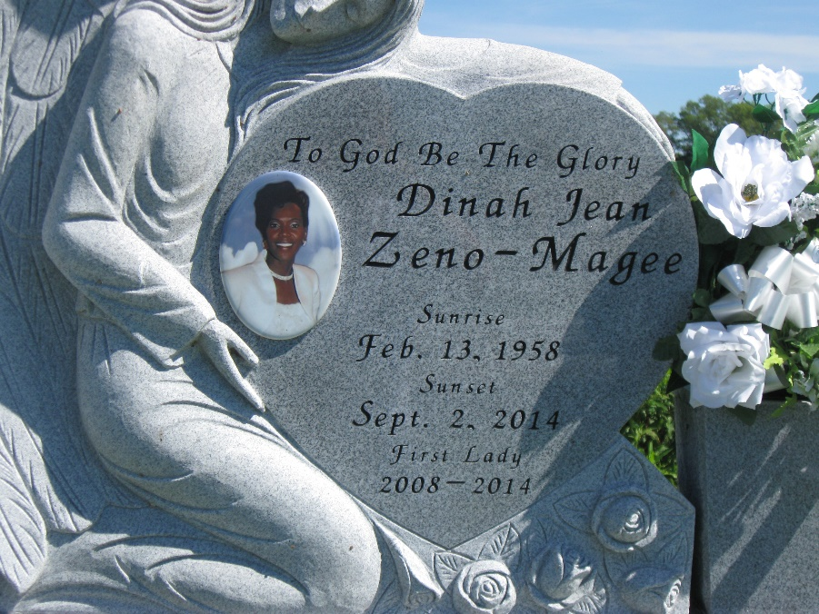
Photo by rw2009

Dinah Zeno Magee, passed away Tuesday, Sept. 2, 2014, at the age of 56. She was the daughter of the late Wyles Zeno Sr. and Celestine Smith Zeno; wife of Pastor Rev. Johnnie Magee; mother of Koi Thompson (James), Deron Batiste Sr. (Kourtney) and the late Johnel Magee; sister of Bobbie Rose (Henry), Wyles Zeno Jr and Evris Zeno. She is also survived by five grandchildren, a host of nieces, nephews, cousins, other relatives and friends.
Funeral services were held at First Baptist Church of Vacherie, on Saturday, Sept. 6. Pastor Rev. Johnnie Magee officiated. Interment was at First Baptist Church Cemetery, Vacherie. The funeral was entrusted to The Baloney Funeral Home. Condolences can be expressed at baloneyfuneralhome.com.

L'Observateur (La Place, LA) - Saturday, September 6, 2014
Contributed by Jane Edson

