Gregory Tyrone Price Sr.
February 18, 1957 – December 29, 2012

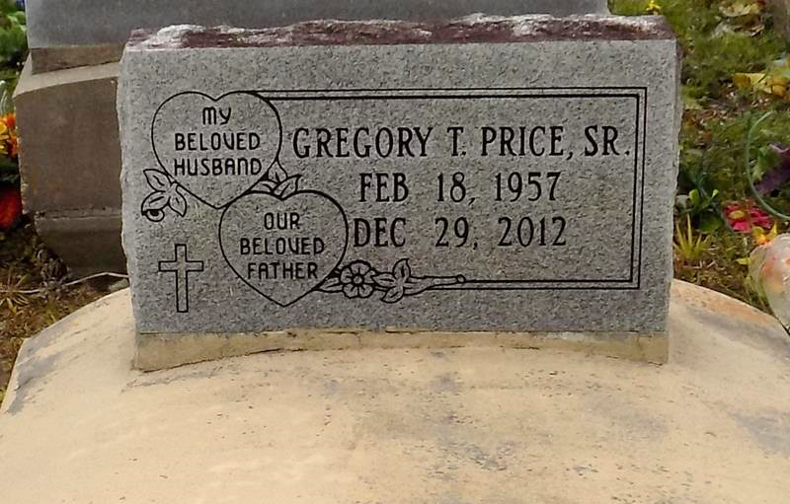

An iron worker, Gregory Price, Sr. passed away on Saturday, December 29, 2012 at 9:02 a.m. at Our Lady of the Lake Regional Medical Center at the age of 55. A native of Natchez, MS and a resident of Vacherie.
Visiting at First Baptist Church 1244 Magnolia Heights, Vacherie on Saturday, January 5, 2013 from 9:00A.M. until Religious Services at 11:00A.M. Conducted by Rev. Johnnie Magee. Interment in Church Cemetery.
He is survived by his wife, Rosa H. Price; his father, Leo Price, Sr.; two daughters and a son-in-law, Joan and Dameion Tureaud of Gramercy and Jaynel A. Price of Vacherie; three sons and a daughter in law, Gregory Price, Jr., Brad A. Price, and Jarrell and Mary Price all of Vacherie; three grandchildren, Jazz Jackson of Lafayette, Jariel Tureaud and Johnaton Riley; eleven sisters and four brothers, aunts, uncles, nieces, nephews, other relatives and friends.
Gregory was preceded in death by his mother, Marguerite C. Price; a devoted stepfather, Herman Collins, Jr.; mother-in-law, Mildred H. Luke; 4 sisters and 3 brothers. Funeral Arrangements entrusted to Demby & Son Funeral Home. Please visit www.dembyandson.com to sign guestbook.
The Advocate, Baton Rouge, Louisiana
Jan. 3 to Jan. 5, 2013.

