Claudia (Fletcher) Steward
December 13, 1945 - October 25, 2006

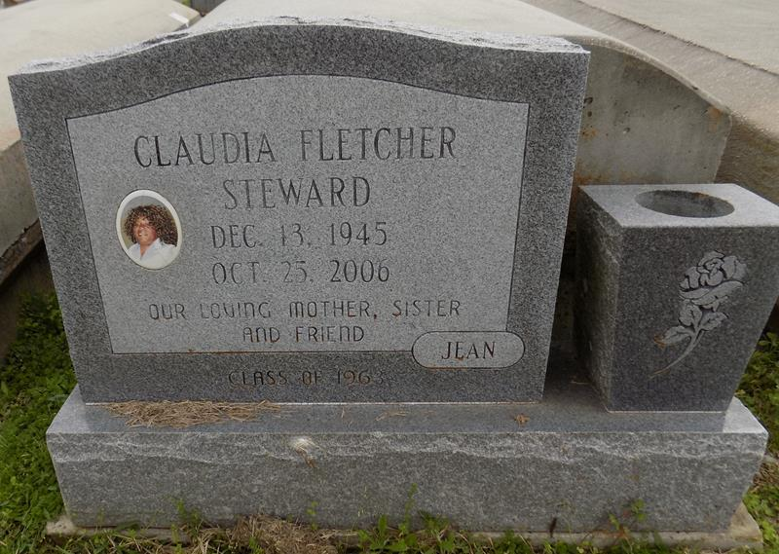

Claudia Fletcher Steward died on Wednesday, October 25, 2006. Daughter of the late Harold and Louella Willliams Fletcher. Devoted wife of the late Nathan Steward. Mother of Yolanda Honore and Brock Miller (Dana). Sister of Rose Best, Jackie Oubre, the late Julia Joseph, James, Harold Jr., Elton Sr., Anthony Sr., Marlis and Allen Fletcher. Also survived by a host of other relatives and friends.
Relatives and friends of the family; also pastors, officers and members of of first Baptist Church are invited to attend the service held on Monday, October 30, 2006 at First Baptist Church, 1234 Magnolia Heights at 11:00 a.m. Visitation will begin at 10:00 a.m. Rev. Lucien Garrett, Sr., officiating. Interment First Baptist Church Cemetery, Vacherie, LA. Arrangements by D.W. RHODES FUNERAL HOME, 1020 Virgil St., Gretna, LA. Please visit our website www.rhodesfuneral.com to sign the guest book.
Published by The Times-Picayune (New Orleans, LA) - Oct. 29, 2006.

