Juanita J. (Taylor) Stewart
January 21, 1933 – January 26, 2006

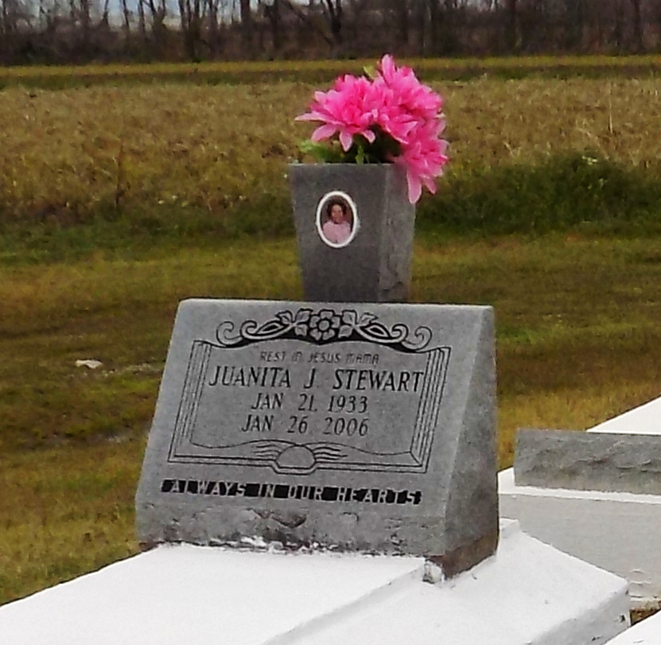

Juanita J. Stewart passed on January 26, 2006 at the age of 73. Daughter of the late Lawrence Taylor and Mary Rapheal Taylor. Mother of Janice Jeffery, Cheryl Bush, Natasha, Terry and Howard Joseph, Jr. and the late Brenda Meggs and Linda Jones. Sister of Claude Florence, George and Warren Taylor and Rose Ann Jones. Grandmother of 14 grandchildren.
Relatives and friends of the family, also pastors, officers and members of 1st B.C. are invited to attend a funeral service held at 11:00 AM on Tuesday, January 31, 2006 at First Baptist Church, 1244 Magnolia Height, Vacherie, LA. Visitation will be from 9:00 AM until 11:00 AM. Interment: First Baptist Church Cemetery.
Arrangements by Rhodes Fidelity Funeral Home, 2929 Scenic Hwy., Baton Rouge, LA.

Published by The Times-Picayune (New Orleans, LA) - Jan. 30, 2006.

