Margaret Stewart
September 3, 1952 – March 3, 2014

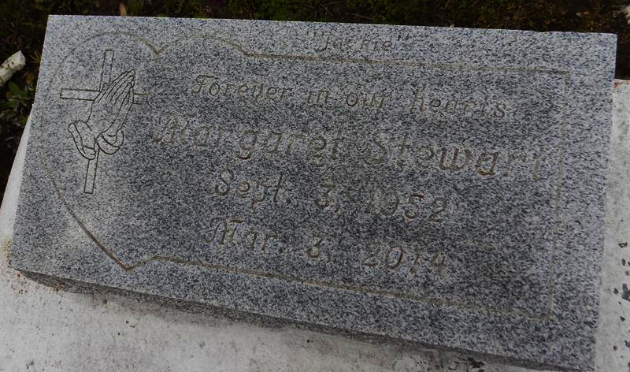

Margaret "Jackie" Stewart, of Vacherie, LA was called home on March 03, 2014 at her residence. Jackie was born September 3, 1952 to Eunice Celestin and the late Overton Jones. She was the loving wife of Alexander Stewart Jr. Mother of Shannon, Shanell, Sharell and Shea Stewart. Grandmother of Tyreik, Shannon, Bryant, Saige, Alayja, Shea'la and Paige. Sister of Leona Washington, Eunice Edwards, Edith Sears, Gerard Smith, Overton, Melba Marie, Owen and Gregory Celestin. Sister-in-law of Maureen and Sophia Broden, Joyce Herbert, Claudette, Luke and Renaldo Stewart. Godmother of Terra Moses, Lilly Guest, Jamal Broden, and the late Jarvis Alexander.
Relatives, friends and parishioners of neighboring communities are invited to attend a home going service on Saturday, March 8, 2015 at First Baptist Church of Vacherie, 1217 Magnolia Heights St., Vacherie, LA.70090 at 11:00 am. Pastor Johnnie Magee will be officiating. Interment will follow at First Baptist Church of Vacherie Cemetery, Vacherie, LA. Funeral services entrusted to The Baloney Funeral Home, LLC, 1905 West Airline Highway, LaPlace, LA., 985-224-8460. Condolences can be expressed at www.baloneyfuneralhome.com.
The New Orleans Advocate, Louisiana; Mar. 6 to Mar. 8, 2014.

