Bryant Keith Thomas Jr.
May 22, 2004 – September 21, 2020

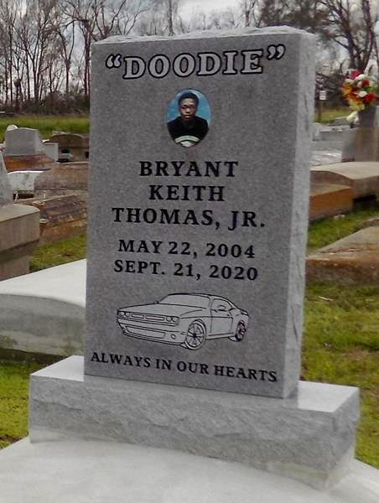

Bryant Keith Thomas, Jr. was born May 22, 2004 in Houma, La to Shanell Stewart and Bryant Thomas Sr. of Vacherie, La. He entered into eternal rest on Monday, September 21, 2020 at Ochsner Medical Center at the age of 16. Bryant was a student at St James High School. He was a determined and competitive young man. Bryant “Doodie” Thomas, Jr. enjoyed spending time with friends, driving, riding four wheelers and playing games. Bryant Jr. accepted Christ as his savior and was baptized May 2014 by Rev. Johnnie B Magee. He attended First Baptist Church until he was called home.
He leaves to cherish his memories his parents Shanell Stewart and Bryant Thomas Sr., brothers Tyreik Stewart and Dathan Thomas (Lashanay), sisters Shiaa Thomas and MiyAsia Thomas, grandfather Alexander Stewart, aunts Sharell Stewart and Beulah Thomas, uncles Shea Stewart (Latoyra), Shannon Stewart, James Thomas (Madeline), Kirk Thomas and John Thomas (Patricia), Godparents Stevenson Champagne, Larry Clarke and Lisha Bazile, first cousins Saige Stewart, Sheala Stewart, Paige Stewart, Shannon Stewart, Aliaja Stewart, Kimberly Zenon (Darrion), Jamie Frazier (Chawn), Lyndell Thomas, Lathon Thomas, Tamika Lockett (David), and a host of cousins, other relatives and friends.
Bryant is preceded in death by his grandmothers Margaret Stewart and Ida Mae Thomas, great-grandparents Beulah and John Thomas and Overton Jones and Eunice Celestine, aunts Leona Washington and Melba Celestin, and cousins Leo Wayne Diggs, Sky Sears, Jenson Washington, Ricky, Jr. and Riley Washington.
A public walk-through viewing will be held on Friday, September 25, 2020 at Treasures of Life Funeral Services 315 E Airline Hwy, Gramercy, LA 70052. Funeral services will be held on Saturday, September 26, 2020 at First Baptist Church 1244 Magnolia Heights, Vacherie, LA 70090 at 11:00 am. Visitation will begin at 9:00 am. Interment to follow at First Baptist Church Cemetery. Final care entrusted to Treasures of Life Funeral Services, 315 E. Airline Highway, Gramercy, LA 70052.

Treasures of Life Funeral Services, Gramercy, LA

