Ida Mae Thomas
October 30, 1934 – March 13, 2020
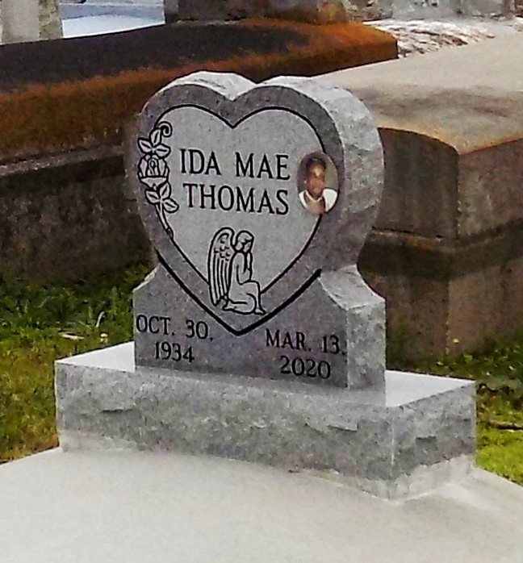

Ida Mae Thomas, a native and resident of Vacherie, passed away peacefully on Friday, March 13, 2020 at AMG Specialty Hospital in Houma, LA. She was the daughter of the late John and Beulah Thomas. She was blessed to be on this earth for 85 years. Ida accepted Christ as her savior and was baptized by the late Rev. Lucien Garrett in 1993. She attended First Baptist Church until her health started declining. Ida loved cooking and baking. She loved listening to gospel music. She had a great love for her family; especially her children and grandchildren, who she enjoyed taking care of no matter what age they were.
Ida leaves to cherish her memories two daughters, Beulah Thomas and Kimberly (Darrion) Zenon, three sons James (Madeline) Thomas, Kirk and Bryant Thomas, eight grandchildren, Tamika (David) Lockett, Leighton (Denine) Oubre, Jamie (Chawn) Frazier, Lendall, MiyAsia, Dathan (Lashanay), Shiaa, and Bryant Thomas, Jr.,sixteen great-grandchildren, two great-great-grandchildren, sister Clara (Alexander) Joseph, brother John (Patricia) Thomas, aunt Dorothy Lewis, one Godchild, Adeline Narcisse, and host of nieces, nephews, other relatives and friends.
She is preceded in death by her parents John and Beulah, grandparents Ida and Joseph Gilbert, uncle Nazrie Hopkins, aunt Paula Celestine, and great-grandson Dathan Thomas, Jr.
Final care entrusted to Treasures of Life Funeral Services, 315 E. Airline Highway, Gramercy, LA.

Treasures of Life Funeral Services, Gramercy, Louisiana

