Gloria Jean Walters
September 6, 1952 – June 11, 2019

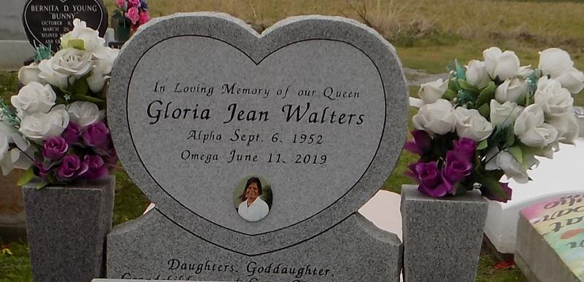

She was predeceased by: her parents, Clarence and Adeline M. Walters Sr.; and her spouse Felton Breaux Sr. She is survived by: her daughters, Michelle and Shemeka Walters; her goddaughter Latricia D. Blain; her grandchildren, Darrell Ambrose Jr., Ryachanelle Morris, Kwantrice Allen, Kaitlyn Zeno, McKensie Jackson and Kendon Broadwater; her great grandchildren, Dacey, Darrell III and Demi Ambrose; her siblings, Oscar Stewart Sr., Clarence Walters Jr. (Linda) and Hamilton Walters; and her friends, Lemar, Rose F. Best, Lena Costley and Rozella Walters. She is also survived by other relatives and friends.
www.echovita.com
*****
A native of Vacherie, Gloria passed away on June 11, 2019 at the age of 66. Visitation 9 A.M. until religious services at 11 A.M. Saturday, June 22 at First Baptist Church, 1244 Magnolia Heights St., Vacherie, LA. Burial in the church cemetery.

Published by The Advocate, Baton Rouge, LA from Jun. 20 to Jun. 22, 2019.

