Patricia Ann (Walters) Blain
June 27, 1955 – July 31, 2014

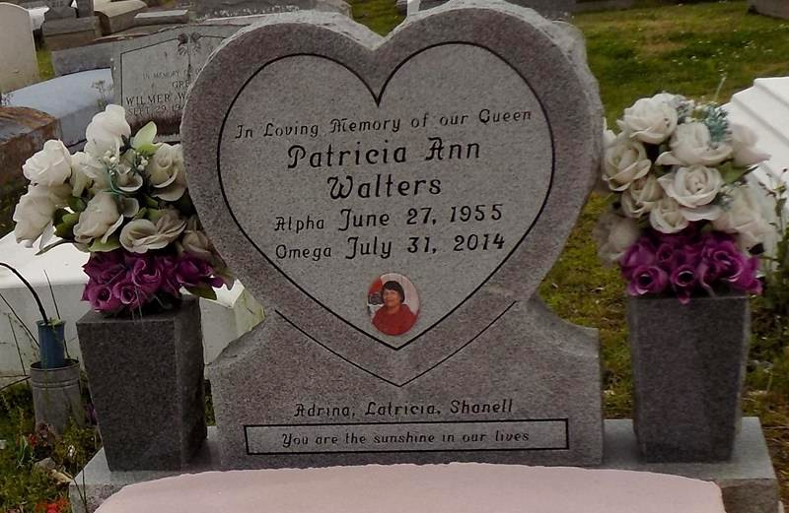

Patricia Ann Walters Blain, passed away Thursday, July 31, 2014 at the age of 59. Daughter of the late Clarence and Adeline Monget Walters, Sr. Wife of Clarence Blain. Mother of Adrina (Wade) Thompson, Latricia Blain and Shanell Walters. Sister of Gloria Jean (the late Felton Breaux) Walters, Oscar Stewart Sr., Clarence (Linda) Walters Jr. and Hamilton Walters, the late Winley (Bettie Ferrygood) Stewart and Nolan Stewart. Grandmother of Adrionna Stewart, Amarion Walters, Darrin Magee. Also survived by a host of nieces, nephews, cousins, other relatives and friends.
Funeral services will be held at New Hope International Family Worship Center, 21490 Highway 20, Vacherie, La. on Saturday, August 9, 2014 for 12:00 p.m. Visitation will be from 10:00 a.m. until time of service. Pastor Claudette Aubert will be officiating. Interment will be at First Baptist Church Cemetery, Vacherie, La. Funeral entrusted to The Baloney Funeral Home, LLC, 1905 W. Airline Highway, Laplace, La., 985-224-8460. Condolences can be expressed at www.baloneyfuneralhome.com.

The New Orleans Advocate, Louisiana; Aug. 1 to Aug. 9, 2014

