Wilmer Warren Washington
September 29, 1942 – February 9, 2011

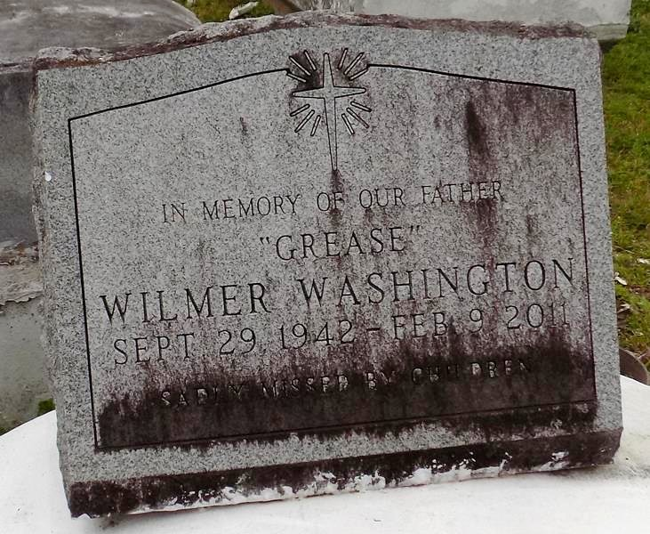

A retired carpenter and resident of Donaldsonville, he died at 4:34 p.m. Wednesday, Feb. 9, 2011, at Prevost Memorial Hospital, Donaldsonville. He was 68 and a native of Vacherie. Visiting at Demby & Son Funeral Home, Donaldsonville, on Thursday, Feb. 17, from 5 p.m. to 7 p.m. Visiting at First Baptist Church, Vacherie, on Friday from 9 a.m. until religious service at 11 a.m., conducted by the Rev. Johnny Magee. Interment in church cemetery.
Survived by his eight daughters, Monica Williams, Dessilene Alexander, Jevelyn Charles, Carmita Vedol, Weneesha Lemar, Gizelle Ross, Tonya Harvey and Shantea Ross; four sons, Tharnell Washington, Shannon Washington, Troy James and Darion Ross; sister, Edna Joseph; two brothers, Henry Washington Jr. and Fred Luke Jr.; 33 grandchildren and three great-grandchildren. Preceded in death by his father, Henry Washington Sr.; and mother, Louise Dozier.

Published by The Advocate (Baton Rouge, LA) - Feb. 16, 2011.

