Lawrence Williams Sr.
February 28, 1928 – September 17, 1993

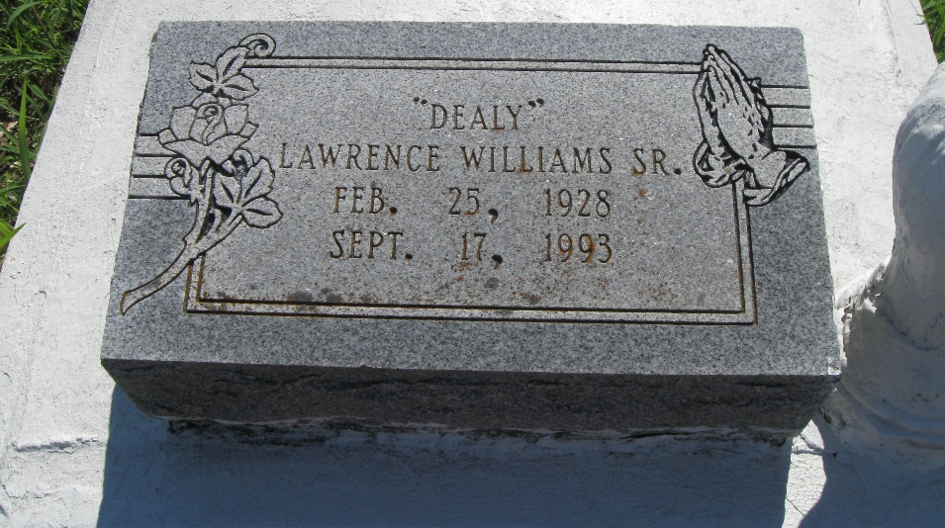
Photo by rw2009

LAWRENCE WILLIAMS

A funeral will be at 8 p.m. Friday at First Baptist Church in Vacherie for Lawrence “Dealy” Williams Sr., 65, a native and resident of Vacherie, who died at 10:20 Friday, Sept 17, 1993. Dismissal will be 11 a.m. Saturday at the church with burial following in the church cemetery. The Rev. Lucien R. Garrett Sr. will officiate.
He was the husband of Onelia Gloster Williams; father of Lawrence Williams Jr., Cleaster Steib, Laverne Jeffery, Annette Gaskin, Philip Augustine Jr., Donald and Rachelle Gloster and Avis Simoneaux; brother of Leona Cage, Eva W. Stewart, Solomon, Cornelius, Israel Bonnie, Matthew Sr. and Thomas Williams II, Ora Bell Rybiskie and Ethel Bell Johnson. He is also survived by nine grandchildren and four great-grandchildren.
He was preceded in death by his parents, Thomas and Sophia Howard Williams; and a brother, Herbert Williams.
Southall-Westside Funeral Home of Vacherie is in charge of arrangements.

Unknown source

