Barbara Ann (Wilson) Zeno
August 10, 1955 – October 17, 2010

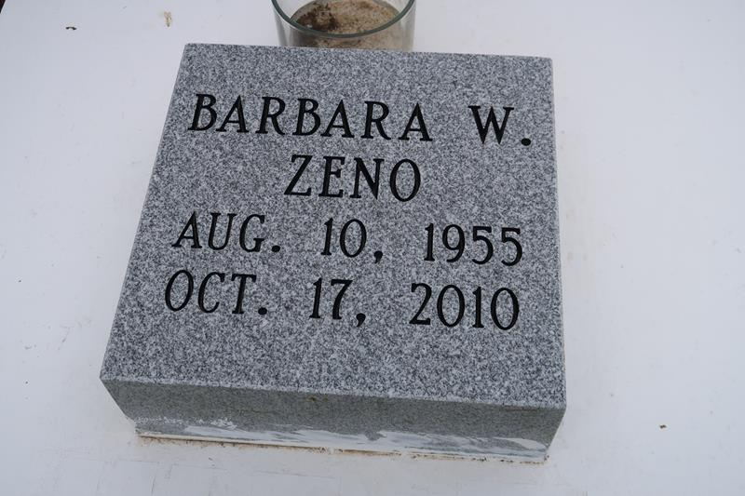

Barbara Ann Wilson Zeno on Sunday, October 17, 2010 at her daughter's home in LaPlace, LA. Daughter of the late Olivia Bibbins and George Wilson, Sr. Wife of Wyles Zeno, Jr. Mother of Taquana Mason (Raydell), Tranada Evans (Troy), Damon Zeno and Theron Zeno. Sister of Kenneth, Joseph and Samuel Wilson, the late Shirley Johnson, George, Jr., Donnell and James Wilson. Daughter in law of Celestine Zeno. Also survived by 4 grandchildren and a host of nieces, nephews, other relatives and friends. Age 55 years. A native of New Orleans, LA and resident of LaPlace, LA.
Relatives and friends of the family, also pastors, officers and members of First Baptist Church, Vacherie, LA, New Rescue Mission Baptist Church of Reserve, LA, Providence #1 and Rising Star Baptist Churches of LaPlace, LA and all neighboring churches and employees of Twin Oaks Nursing Home and Healing Hands Staffing are invited to attend the funeral at First Baptist Church, 1244 Magnolia Heights, Vacherie, LA, on Saturday, October 23, 2010 at 11:00 AM. Rev. Johnnie Magee, Pastor, Officiating. Interment First Baptist Church Cemetery, Vacherie, LA. Visitation at the above named church from 10:00 AM until Service time. SERVICED BY ROBOTTOM.

Published by The Times-Picayune (New Orleans, LA) - Oct. 22, 2010

