Charles Bowser
September 24, 1987 – September 24, 2007

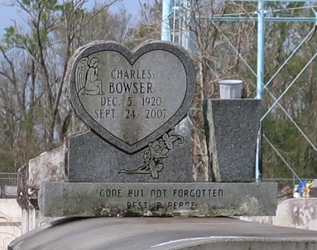
Charles Bowser departed life at 2:30 AM on Monday, September 24, 2007 at Health West Rehabilitation Hospital at the age of 86 years old. He was the devoted husband of Catherine Bowser for (54) years. Father of four sons, Jerry and Raymond Williams, Cedric and Harold Bowser. Son of the late Willie Bowser Sr. and Pearl Peters Bowser, Brother of Dennis (Debra) Washington, and Onetta Washington of Lutcher, LA. He was proceeded in death by his siblings Ethel M. Skinner, Josie M. Wallace, Mildred Albert, Erma Jean Goff, Dorothy Mitchell, Bernice Washington, Willie Bowser, Jr. and Anthony Johnson, Sr. He leaves to cherish his memory 7 grandchildren and 8 great grandchildren and a host of nieces and nephews, relatives and friends.
The family invites the pastor, officers and members of King Triumph Baptist Church and neighboring churches in Lutcher, Louisiana. Charles was an active member in Winter Capital Lodge #595, Young Men of Distinction #1677, the Elks family of the I. B. P. O. E. of the World, D. A V. Chapter #13, Veterans of Foreign Wars #1749, American Legion Post #555, and the Royal 25 Social and Pleasure Club, members and officers are invited to attend the Funeral Services at Isrealite Divine Spiritual Church, 3000 Frenchmen St., New Orleans, La. Saturday, September 29, 2007 10:00am. Visitation will begin at 9:00am. A dismissal will be held at King Triumph Baptist Church in Lutcher, La. at 12:00 noon. Interment: Golden Wreath Cemetery, Luthcher, La. Funeral arrangements by Rhodes Funeral Home - 1728 N. Claiborne Ave.
Times-Picayune, The (New Orleans, LA)
Friday, September 28, 2007

