Floyd Brooks Sr.
April 3, 1945 – February 4, 2005

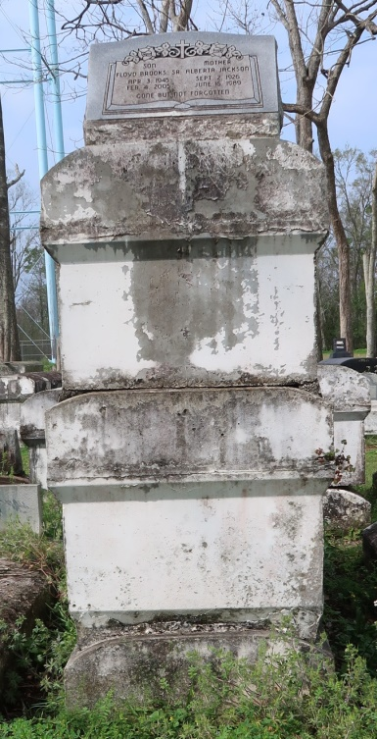
Floyd Brooks Sr., a retired laborer, died Friday of a heart attack at Canon Hospice. He was 59. Mr. Brooks was born in New Orleans and lived in Laplace.
Survivors include five sons, Floyd Brooks Jr., Elijah Campbell, and Lloyd, Cortez and Jarrod Brooks; six daughters, Eloise Dixon, Vanessa McKarry, Shawn Watkins, Kim Frost, Cheryl Hemphill and Melissa Hamilton; three brothers, Horace, Morris and Rogers Brooks; six sisters, Nita Mae Persade, Lois Jackson, Albertha Skidmore, Joann Marie Cook, Janice Williams and Ruth Brooks; 32 grandchildren; and five great-grandchildren.
A funeral will be held today at 11 a.m. at Mount Olive Baptist Church, 3143 Louisiana 642, Paulina. Visitation will begin at 9 a.m. Burial will be in Golden Wreath Cemetery, Lutcher. Hobson Brown Funeral Home is in charge of arrangements.
Times-Picayune, The (New Orleans, LA)
Thursday, February 10, 2005

