Eloise Marie (Brooks) Dixon
August 26, 1962 – January 18, 2013

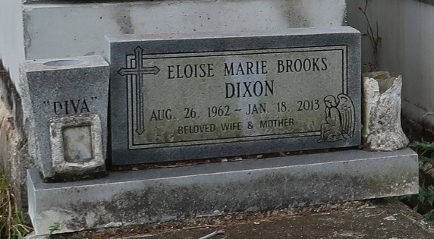
Eloise Brooks Dixon
A resident of Reserve, she died at 11:07 a.m. Friday, Jan. 18, 2013, at River Parishes Hospital, LaPlace. She was 50 and a native of Lutcher. Visiting at New Zion Christian Center, Gramercy, on Saturday, Jan. 26, from 9:30 a.m. until religious service at 11 a.m., the Rev. Emil D. Mitchell, pastor, and the Rev. Wesley Anderson, Jr., officiating. Interment in Golden Wreath Cemetery, Lutcher.
Survived by her husband, Warren Dixon; mother, Marva Robertson Brooks; son, Christopher Brooks; six sisters and their spouses, Vanessa and Michael McKarry, Cheryl and Darwin Joseph, Kim and John Frost, Eliszha Cambell, Shawn Watkins and Melissa Lucas; six brothers, Floyd Brooks, Jr., Lloyd Brooks, Jr., Cortez Brooks, Jarrod Brooks, Derick (Melinda) Robertson and Wilma Davis, III; mother-in-law, Carolyn Isom; sisters-in-law, brothers-in-law, aunts, uncles, nieces, nephews, cousins, other relatives and friends. Preceded in death by her father, Floyd Brooks, Sr.; and maternal and paternal grandparents.
Arrangements by Brazier-Watson Funeral Home, Donaldsonville. Visit www.brazierwatson.com to sign the guest book.

Advocate, The (Baton Rouge, LA)
Wednesday, January 23, 2013

